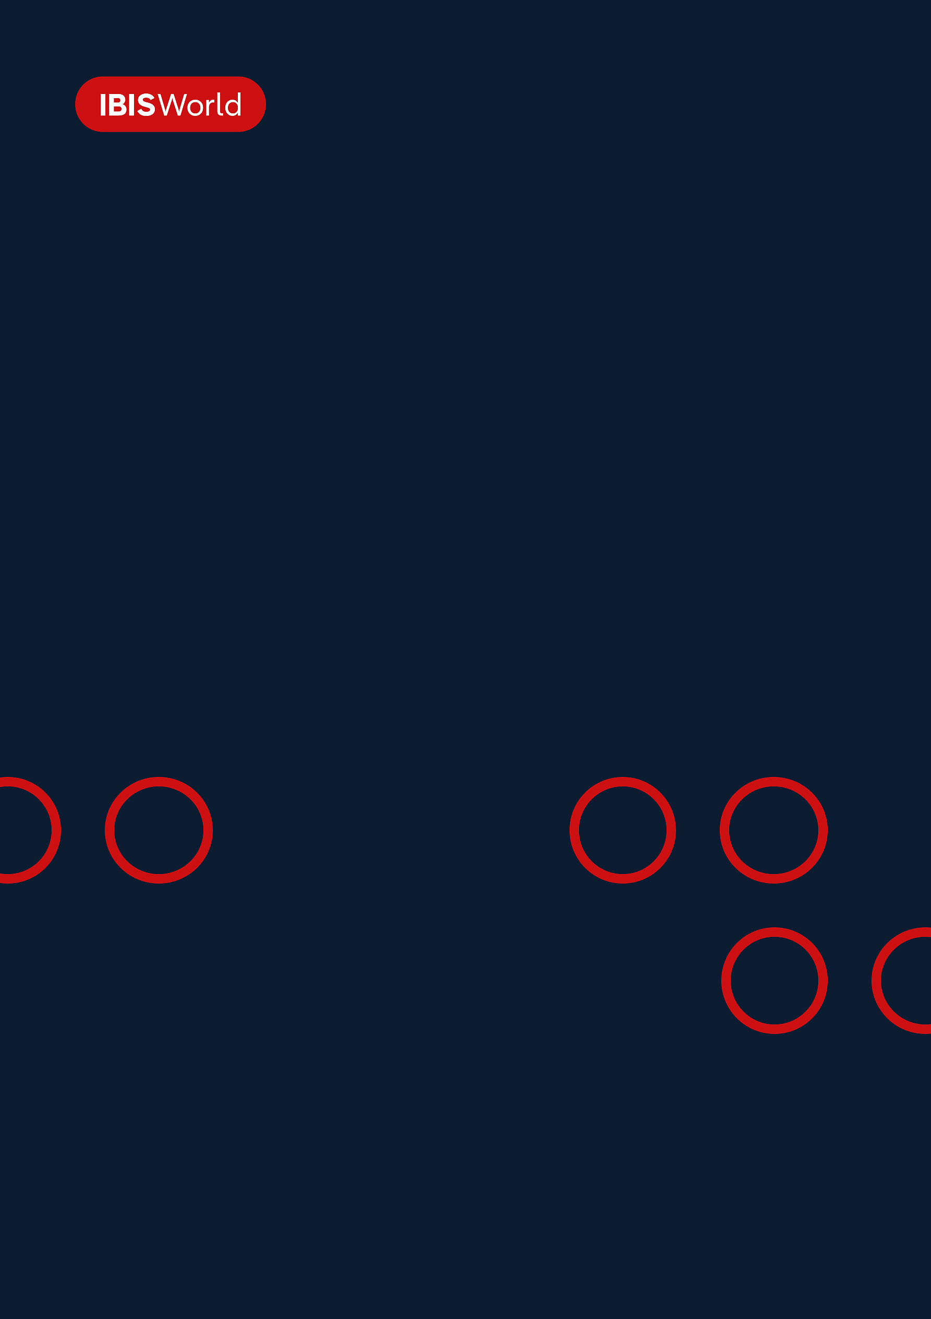
INDUSTRY REPORT
Stevedoring & Marine Cargo Handling in the US
Nov 2025

About

IBISWorld
IBISWorld specializes in industry research with coverage on thousands of global industries. Our comprehensive data and in-depth analysis help businesses of all types gain quick and actionable insights on industries around the world. Busy professionals can spend less time researching and preparing for meetings, and more time focused on making strategic business decisions.

Table Of Contents | Standard

1. About 4
Codes 4
Definition 4
Related Terms 4
What's Included 5
Companies 5
Related Industries 5
Additional Resources 6
2. At a Glance 7
Key Takeaways 7
Products and Services 8
Major Players 9
Key External Drivers 10
Industry Structure 10
SWOT 11
Executive Summary 11
3. Performance 13
Highlights 13
Key Takeaways 13
Performance Snapshot 14
Outlook 22
Life Cycle 24
4. Products and Markets 25
Key Takeaways 25
Products and Services 25
Major Markets 29
International Trade 31
5. Geographic Breakdown 32
Key Takeaways 32
Business Locations 33
6. Competitive Forces 42
Key Takeaways 42
Concentration 42
Barriers to Entry 44
Substitutes 45
Buyer & Supplier Power 46
7. Companies 49
Key Takeaways 49
Market Share 50
Companies 51
8. External Environment 56
Key Takeaways 56
External Drivers 56
Regulation & Policy 59
Assistance 61
9. Financial Benchmarks 63
Key Takeaways 63
Cost Structure 64
Financial Ratios 68
Valuation Multiples 74
Key Ratios 75
10. Key Statistics 77
Industry Data 77

1. About
https://my.ibisworld.com/us/en/industry/48832/about

Codes
NAICS 2017 - USA | 48832
NAICS 2017 - USA | 488320
NAICS 2022 - USA | 48832
NAICS 2022 - USA | 488320

Definition
Companies in this industry provide stevedoring and other marine cargo handling services. A stevedore is a company or individual that is usually contracted by an agent to load and unload cargo from a ship in port.

Related Terms

LONGSHOREMAN
A laborer who loads and unloads marine cargo; also called a \"stevedore.\"

LASHING
The process of securing containers to each other and to the ship with a system of ropes.

INTERNATIONAL LONGSHORE AND WAREHOUSE UNION (ILWU)
A labor union that represents dockworkers in the West region of the United States (and in parts of Canada).

BULK CARGO
Commodity cargo that is transported unpackaged.

CONTAINER CARGO
Cargo, ranging from automobiles to food to consumer goods, which is uniformly packaged in standard-size containers.

INTERMODAL TRANSPORTATION
A shipment that spans more than one mode of transportation (e.g. water and land).

STACKER-RECLAIMERS
Machines used to scoop bulk materials from and into piles.

PORTAINERS
Bulk ship-to-shore cranes.

GANTRIES
Frames used to support traveling cranes.

TWENTY-FOOT EQUIVALENT UNIT (TEU)
A unit of carrying capacity for container ships. This unit measures the number of standard 20x8x8 foot containers a ship can transport.

STEVEDORE
A person employed at a dock to load and unload cargo from ships.

What's Included
- Stevedoring
- Waterfront terminal management
- Waterfront consulting and project management
- Cargo loading and inspection

Companies
- Ports America Inc.
- SSA Marine Inc.

Related Industries

Industries in the Same Sector
- Competitors:
  - No data available
- Complementors:
  - Port & Harbor Operations in the US
  - Dry Dock & Cargo Inspection Services in the US
  - Freight Packing & Logistics Services in the US
  - General Warehousing & Storage in the US
  - Refrigerated Storage in the US
  - Specialized Storage & Warehousing in the US

International Industries
- Stevedoring Services in Australia
- Stevedoring and Water Transport Support Services in New Zealand

Additional Resources
- American Association of Port Authorities
- International Maritime Organization
- Occupational Safety and Health Administration
- International Longshore and Warehouse Union

2. At a Glance
https://my.ibisworld.com/us/en/industry/48832/at-a-glance
Revenue  $15.4bn  ’20-’25 ↑ 4.2 %  ’25-’30 ↑ 1.4 % | Employees  67,522  ’20-’25 ↑ 0.2 %  ’25-’30 ↑ 1.2 % | Businesses  286  ’20-’25 ↑ 1.1 %  ’25-’30 ↑ 0.9 %
Profit  $1.7bn  ’20-’25 ↑ 16.4 % | Profit Margin  10.8%  ’20-’25 ↑ 4.6 pp | Wages  $6.4bn  ’20-’25 ↑ 1.6 %  ’25-’30 ↑ 1.2 %

Key Takeaways

Performance
- The fiscal stimulus measures unleashed pent-up consumer demand, driving the total trade value in 2021 and 2022. Elevated imports pressured domestic port infrastructure, leading to congestion and longer vessel wait times. Still, this resulted in a greater need for stevedoring and marine cargo handling.
- The Bipartisan Infrastructure Deal allocated $2.25 billion to expand domestic ports and harbors through the Port Infrastructure Development Program (PIDP) Grants. The investment is expected to improve capacity and support the performance of US commercial ports, driving the expansion of international trade.
- Integrating AI and cloud solutions is anticipated to drive revenue growth. Adopting new technologies is set to improve efficiency, lower vessel turnaround times and increase cargo loading and unloading capabilities.
- Port throughput is running strong in 2025. The Port of Los Angeles set monthly and quarterly records, with year-to-date TEUs above 2024 levels, signaling resilient demand as companies front-loaded on goods ahead of tariffs.

Products and Markets
- Volatility in energy markets has bolstered demand for oil, gas and chemical stevedoring services. The war in Ukraine and the following sanctions on Russia led the US and other countries to fill the supply gap.
- Tightened monetary policy moderates trading activity in container stevedoring despite rising consumer spending. Higher interest rates and rising credit card debt limited consumers' discretionary spending and impacted the segment's growth.

Products and Services
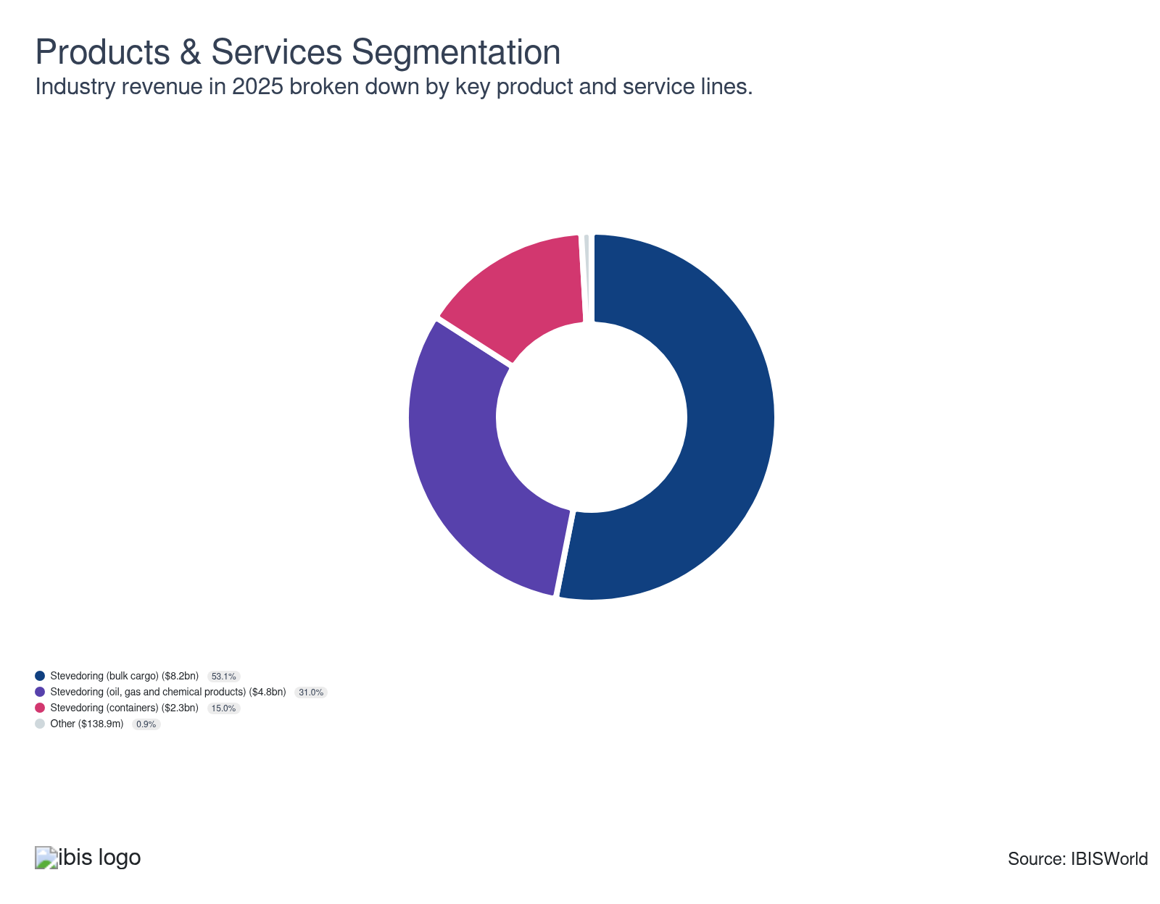

Major Players
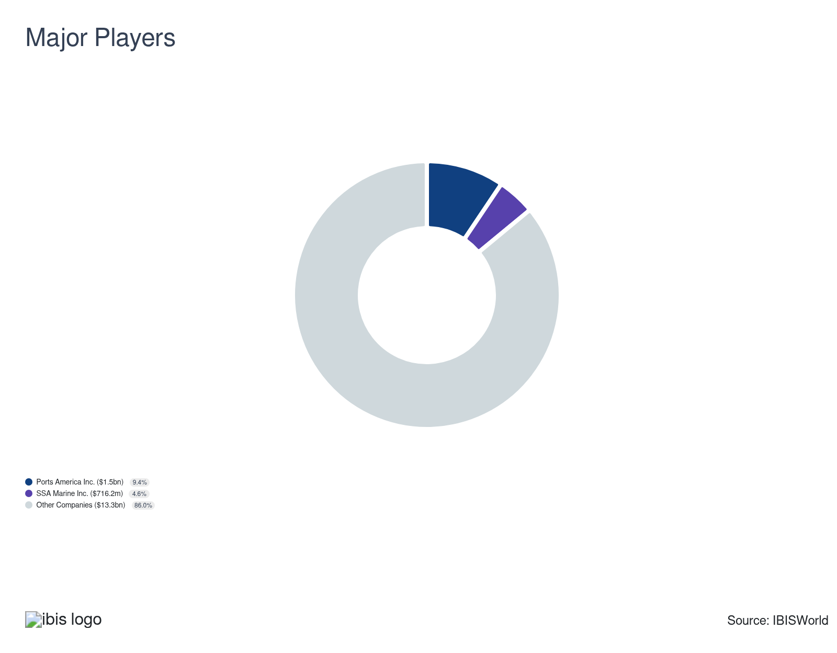

Key External Drivers
Key External Drivers | Impact
Total trade value | Positive
Consumer spending | Positive
Freight transportation services index | Positive
Industrial production index | Positive
World price of crude oil | Positive

Industry Structure
Characteristic | Level | Trend
Concentration | Low
Barriers To Entry | High | Increasing
Regulation and Policy | Moderate | Steady
Life Cycle | Mature
Revenue Volatility | Moderate
Assistance | Low | Steady
Competition | Moderate | Steady
Innovation | Low

SWOT
Strengths  High & Increasing Barriers to Entry  Low Imports  High Profit vs. Sector Average  Low Customer Class Concentration  High Revenue per Employee  Low Capital Requirements | Weaknesses  Low & Steady Level of Assistance  High Product/Service Concentration | Opportunities  High Revenue Growth (2020-2025)  High Revenue Growth (2025-2030)  High Performance Drivers | Threats  Low Revenue Growth (2005-2025)  Low Outlier Growth  World price of crude oil

Executive Summary

Uncharted waters: Rising trade volumes and consumer spending are set to drive revenue growth
A surge in consumer spending, fueled by fiscal stimulus and rising disposable incomes, boosted port demand in recent years. Higher demand accelerated purchases of discretionary goods, driving containerized import volumes and pushing aging port infrastructure to its limits. Congestion responses included shorter tariff-free dwell times and new surcharges to speed cargo flows. At the same time, sanctions on Russian energy shifted global supply, enabling US petroleum and LNG exports to backfill European demand and lift Gulf Coast throughput. Stevedores leveraged this volume spike and process automation to expand profit, which rose from 6.2% of revenue in 2020 to 10.8% in 2025, even as inflation raised operating costs. Across the current period, revenue grew at a 4.2% CAGR to $15.4 billion, with a temporary 0.8% drop in 2025 as tariffs and tighter financial conditions tempered import growth.
In response to volatile demand at the beginning of the period, terminal operators rationalized footprints, deepened partnerships with carriers and invested in specialized equipment. Automated electric cranes, stackers and digital yard systems reduced turnaround times and reliance on manual labor toward the end of the period. While higher interest rates compelled companies to reduce capital expenditures, the resilient economic activity and e-commerce growth kept import demand intact. Export strength in energy and chemicals provided an offset. Tariffs played a two-sided role since they pressured imports of China-origin goods and complicated routing. Still, they encouraged nearshoring flows from Mexico and diversified Asia, stabilizing volumes across coasts. Together, these forces sustained profit improvements alongside selective headcount reductions and process optimization.
A less restrictive monetary stance should gradually boost consumer spending and industrial output, but growth will be driven by productivity more than volume. Federal port investment and private capital (with AI, cloud orchestration and automated guided vehicles) will expand capacity and data-driven planning, lifting crane productivity and berth utilization. Tariff policy remains a key external driver. However, prolonged reciprocity could dampen specific import lanes even as nearshoring and energy exports underpin baseline activity. As automation matures and scale benefits accrue, profit is likely to reach 11.4% by 2030, with industry revenue increasing at a 1.4% CAGR over the next five years to $16.5 billion.

3. Performance
https://my.ibisworld.com/us/en/industry/48832/performance

Highlights
Revenue  $15.4bn  2020-25 CAGR ↑ 4.2 %  2025-30 CAGR ↑ 1.4 % | Employees  67,522  2020-25 CAGR ↑ 0.2 %  2025-30 CAGR ↑ 1.2 % | Businesses  286  2020-25 CAGR ↑ 1.1 %  2025-30 CAGR ↑ 0.9 %
Profit  $1.7bn  2020-25 CAGR ↑ 16.4 % | Profit Margin  10.8%  2020-25 CAGR ↑ 4.6 pp

Key Takeaways
- The fiscal stimulus measures unleashed pent-up consumer demand, driving the total trade value in 2021 and 2022. Elevated imports pressured domestic port infrastructure, leading to congestion and longer vessel wait times. Still, this resulted in a greater need for stevedoring and marine cargo handling.
- The Bipartisan Infrastructure Deal allocated $2.25 billion to expand domestic ports and harbors through the Port Infrastructure Development Program (PIDP) Grants. The investment is expected to improve capacity and support the performance of US commercial ports, driving the expansion of international trade.
- Integrating AI and cloud solutions is anticipated to drive revenue growth. Adopting new technologies is set to improve efficiency, lower vessel turnaround times and increase cargo loading and unloading capabilities.
- Port throughput is running strong in 2025. The Port of Los Angeles set monthly and quarterly records, with year-to-date TEUs above 2024 levels, signaling resilient demand as companies front-loaded on goods ahead of tariffs.

Performance Snapshot
Revenue: | ↑ 2020-25 Revenue CAGR +4.2%
Revenue  $15.4bn  ’20-’25 ↑ 4.2 %  ’25-’30 ↑ 1.4 % | 2025 Revenue Growth  ↓ 0.8 % | Revenue Volatility  Moderate
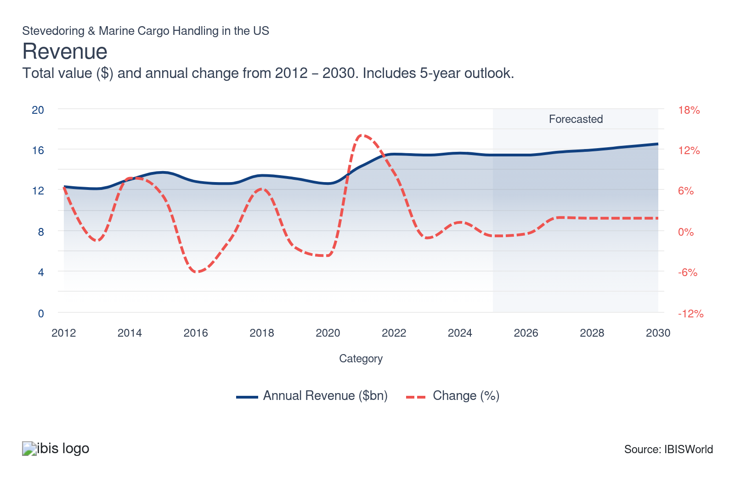
Employees: | ↑ 2020-25 Employees CAGR +0.2%
Employees  67,522  ’20-’25 ↑ 0.2 %  ’25-’30 ↑ 1.2 % | Employees per Business  236  ’20-’25 ↓ 0.9 %  ’25-’30 ↑ 0.3 % | Revenue per Employee  $229k  ’20-’25 ↑ 4.0 %  ’25-’30 ↑ 0.2 %
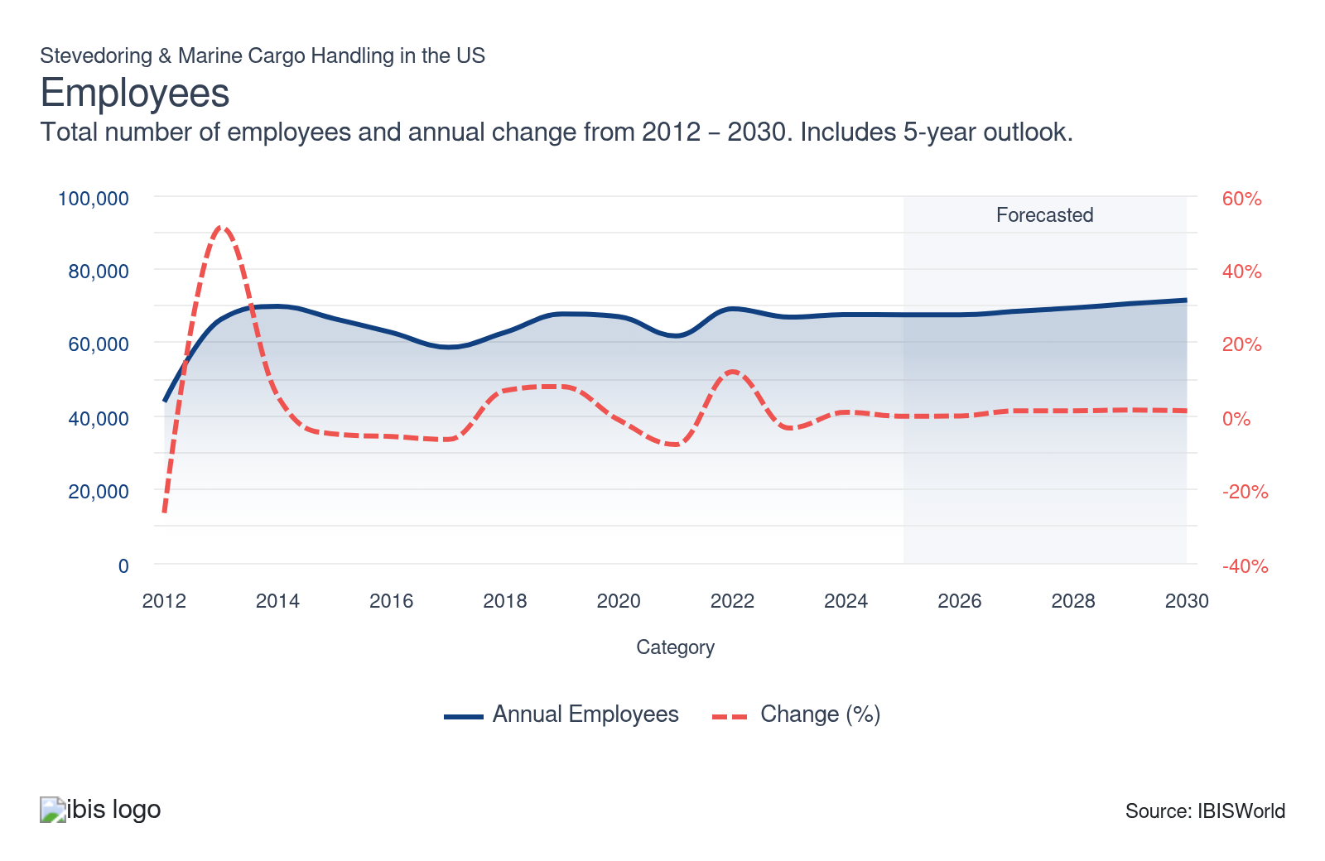
Businesses: | ↑ 2020-25 Business CAGR +1.1%
Businesses  286  ’20-’25 ↑ 1.1 %  ’25-’30 ↑ 0.9 % | Employees per Business  236  ’20-’25 ↓ 0.9 %  ’25-’30 ↑ 0.3 % | Revenue per Business  $54.0m  ’20-’25 ↑ 3.1 %  ’25-’30 ↑ 0.5 %
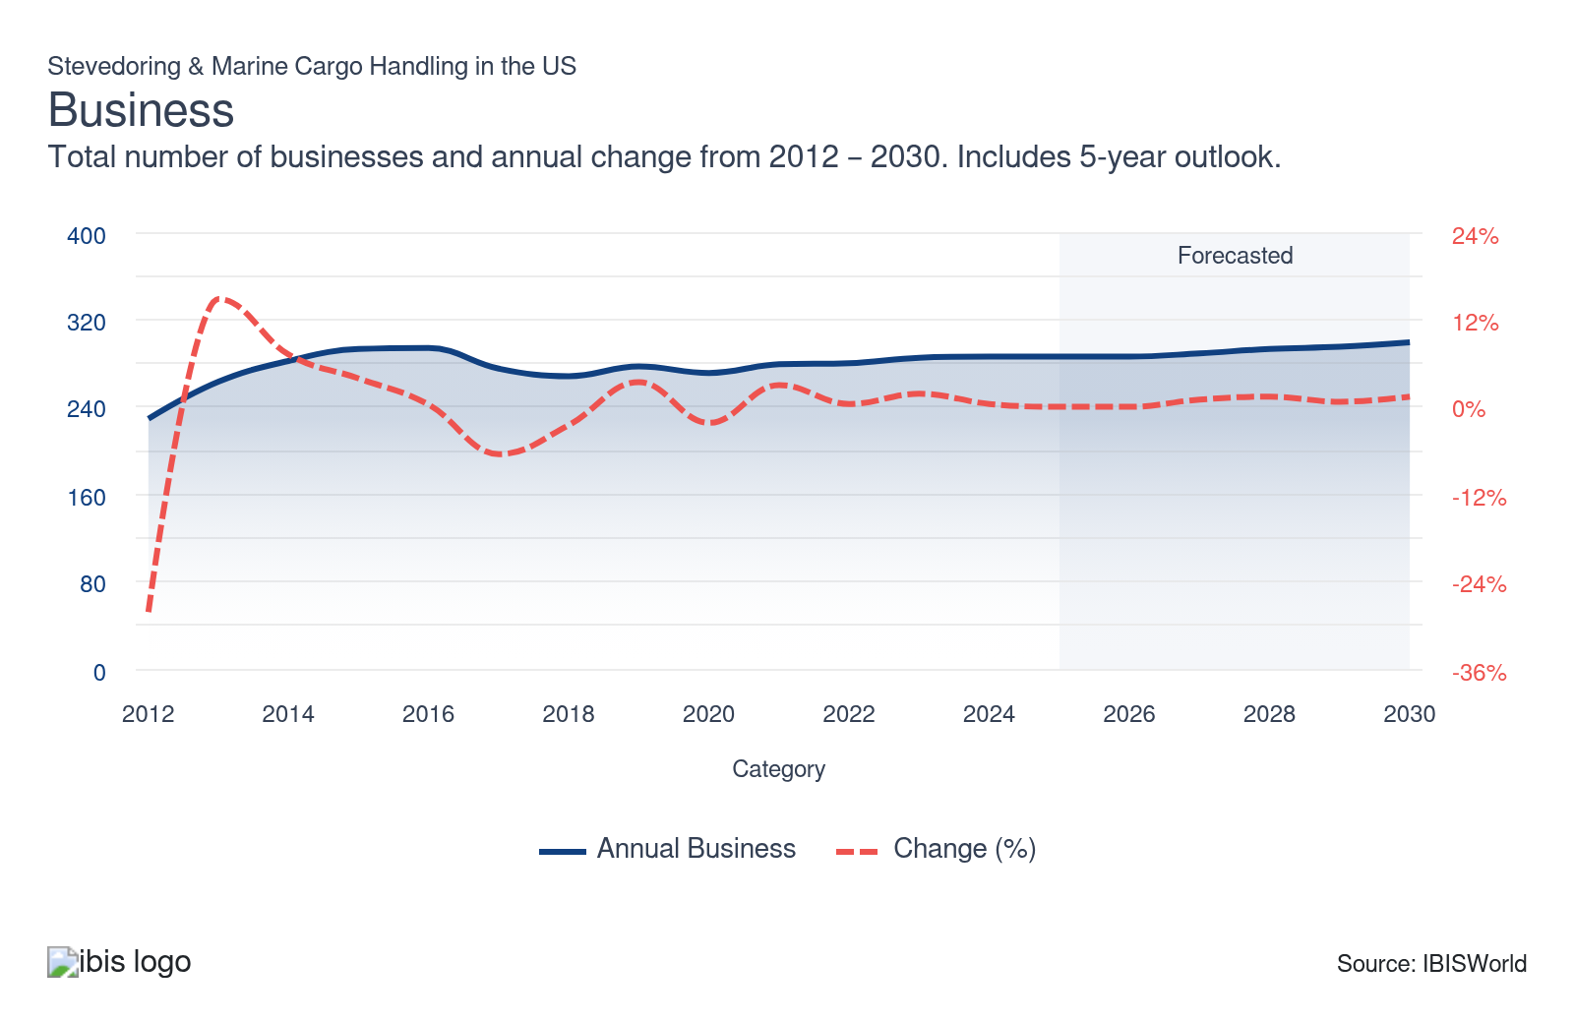
Profit: | ↑ 2020-25 Profit CAGR +16.4%
Total Profit  $1.7bn  ’20-’25 ↑ 16.4 % | Profit Margin  10.8%  ’20-’25 ↑ 4.6 pp | Profit per Business  $5.8m
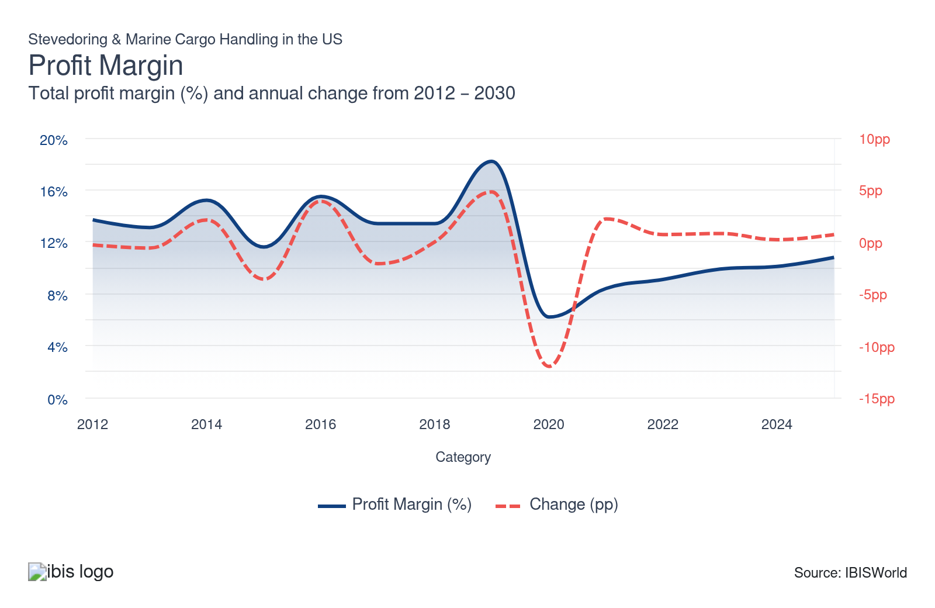
Current Performance
Current Performance

What's driving current industry performance?

Fiscal stimulus and supply chain disruptions drive performance
- Rising disposable income levels boosted the manufacturing of discretionary goods. Stimulus measures starting in 2020 prompted consumers to increase spending, unleashing pent-up demand, which drove the expansion of total trade value in 2021 and 2022.
- An influx of imported goods from Asia flooded the domestic markets, pressuring the outdated infrastructure of domestic ports. A container build-up resulted in rising wait times, which pressured the turnaround time of vessels entering the ports. According to Danny Wan, an executive director for the Port of Oakland, in 2022, the port reduced the tariff-free wait time for vessels from seven to four days to reduce congestion, with major ports considering surcharges to speed up cargo turnover.
- Efficiency in cargo handling remains critical in maintaining a quick turnaround time for vessels and alleviating pressure from the supply chain. Rising congestion in ports caused by soaring trade value drove revenue growth for stevedores, who remain the anchor for the prompt distribution of goods.

Liquefied natural gas shipments and crude oil loading boosted revenues at gulf terminals
- Sanctions on Russian oil and gas created a supply gap, driving up the energy prices. Domestic producers ramped up production and exported petroleum and LNG products to Europe to capitalize on rising prices, boosting the traffic of oil and gas tankers going in and out of ports.
- Despite the tensions in the Middle East and the war between Israel and Hamas, the energy markets are beginning to stabilize as supply meets demand. The Enbridge Ingleside Energy Center became the largest crude oil export terminal by volume in North America, loading an average of 25.0% of all US Gulf Coast crude exports annually with three deep-water vessel berths capable of loading very large crude carriers up to 1.5 million barrels.
- According to company statements, LNG terminals also generated employment and handling activity, with facilities like Golden Pass LNG expecting to hire around 200 new direct employees for operations, maintenance, engineering, safety and commercial positions. The specialized nature of energy-related stevedoring and marine cargo handling required handlers to invest in safety systems, firefighting equipment, environmental controls and trained personnel capable of managing hazardous materials and high-value shipments under strict regulatory oversight.​

Consumer spending and import surges lifted port handling volumes before freight recession
- Revenue in stevedoring and marine cargo handling expanded during the beginning of the period as containerized import volumes reached all-time highs following the pandemic disruption. According to United Nations data, US container ports handled 61.0 million TEUs in 2022. The stevedoring and marine cargo handling industry employed 69,158 people in 2022, with a total annual payroll of $6.6 billion in 2022. These statistics reflect the surge in cargo activity across major port facilities.
- In 2023, a freight recession caused by interest rate increases raised the cost of holding inventory since fewer vessel calls and lower container volumes reduced per-TEU handling fees and equipment rental income. Inflation pressured consumers to reduce spending on discretionary goods, weakening retail demand and discouraging import orders. According to the United Nations, US ports recorded an 11.1% drop in container shipments, contributing to lower revenue in 2023.
- Despite subdued performance in 2023, consumer sentiment is improving, with total trade value rebounding through the first half of 2024. According to CBRE, the 14 major US ports reported an average rise in cargo volume of 15.0% on a year-over-year basis, meeting output levels from 2022. The return to volume growth in 2024 reflects retailers completing inventory adjustments and resuming standard ordering patterns, though future expansion faces headwinds from shifting trade policies and economic uncertainty.
- Container shipment volumes continued to climb in the first and second quarters of 2025 as businesses front-loaded on goods ahead of tariffs. They will reduce imports afterward because they have enough supply to last through the holiday season. In September 2025, import volumes at the Port of Los Angeles were already down 7.51%.

Automation investments and industry mergers reshaped labor economics while preserving skilled positions
- Stevedoring and marine cargo handling wages increased to $6.4 billion in 2024 before slightly dropping after tariff pressures accelerated. The divergence between rising wages and relatively flat employment reflects the industry's transition toward capital-intensive operations that require fewer but more highly skilled workers to manage automated systems.
- Enterprise growth occurred as larger operators acquired smaller terminals to achieve economies of scale, access specialized technologies and expand geographic reach. In 2023, according to WSJ, Carrix's subsidiary, SSA Marine, acquired Ceres Terminals for around $1.0 billion. Acquisitions like this will strengthen economies of scale for stevedoring and marine cargo handling companies.
- Terminal operations depend on specialized machinery such as gantry cranes, straddle carriers and reach stackers, which can all be automated. If firms implement upskilling programs, hybrid human-machine systems and flexible labor deployment strategies, they can limit wage and employment growth, boosting profit margin.

What influences industry volatility?

Tariffs and consumer spending patterns influence stevedoring and marine cargo handling performance
- Fluctuations in the total trade value directly impact demand for cargo-related services, including stevedoring. Revenue volatility was linked to varying shipping volumes and the amount of cargo being delivered.
- Rising inflation resulted in tightened monetary policy, which pressured total trade value as consumers pulled back and reduced spending on discretionary items. Tariff implementation also reduced the trade value, with many businesses reducing imports after front-loading on goods.

Volatile energy prices can influence the trade value
- The sanctions on Russian oil and gas prompted a spike in the global energy markets as Europe struggled to secure the needed supply to fuel its needs. Rising energy prices prompted domestic drilling and extraction sites to ramp up production and capitalize on rising prices, boosting oil exports.
- As more suppliers raised energy production, the markets adjusted to the initial shock and the world price of crude oil moderated. The stabilization occurred amid a more stable supply and economic uncertainty caused by tightened monetary policy.
- In October 2025, the US imposed sanctions on Russia to disrupt its largest oil producers, Rosneft and Lukoil, in an effort to end the war in Ukraine. If geopolitical tensions continue to escalate, crude oil prices may surge further, leading to higher trade values and revenue volatility.

Fiscal stimulus supports a stable port environment
- The Infrastructure Investment and Jobs Act (IIJA) directly supports stevedoring and marine cargo handling services through its Port Infrastructure Development Program (PIDP), administered by the U.S. Department of Transportation’s Maritime Administration (MARAD). The IIJA provides $2.25 billion between 2022 and 2026 to fund competitive grants for projects that improve the efficiency, safety and reliability of cargo movement through ports. While the legislation does not provide funds to private stevedoring firms directly, it supports the public port infrastructure they depend on. These are wharves, loading equipment, on-dock rail and berth expansions. The Infrastructure Investment and Jobs Act (IIJA) under the Biden administration helped increase investment for port infrastructure and caused trade values to surge early in the period. The Port Infrastructure Development Program (PIDP), which is responsible for funding stevedoring and marine cargo handling projects, will
- Fiscal programs like the PIDP enhance the infrastructure and operational environment for stevedoring and marine cargo handling companies by funding the modernization of port equipment and the transition to cleaner, more automated handling systems that improve port productivity and sustainability.​ Without these programs, US ports will be less attractive for foreign direct investment, which may create a volatile environment for stevedoring and marine cargo handling services.
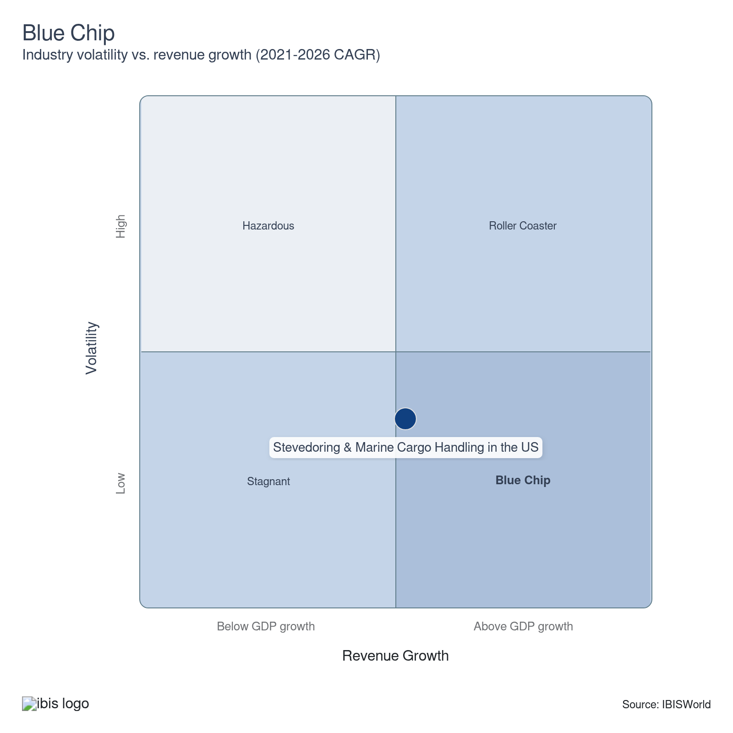

How do successful businesses overcome volatility?
Optimize operating capacity
Stevedoring and marine cargo handling companies can effectively balance supply and demand by optimizing their operating capacity. The flexibility allows them to handle varying volumes without compromising efficiency, which is crucial during market volatility.
Develop a strong reputation
A strong reputation attracts consistent business and fosters trust with clients. Reliability is essential for securing long-term contracts and weathering market volatility.
Outlook | ↑ 2025-30 Revenue CAGR +1.4%

What's driving the industry outlook?

Strong consumer sentiment and growing industrial production contribute to strong outlook
- The expected easing of monetary policy will drive consumer spending as interest rates on credit card debt decline and business hiring levels improve because of increased liquidity. Stabilizing consumer sentiment will drive the expansion of total trade value, which will, in turn, strengthen the turnover rate of cargo in domestic ports.
- A more optimistic consumer outlook is expected to drive spending on leisure and entertainment, benefiting cruise lines as consumers ramp up discretionary spending despite rising . A recovery of cruises is set to drive the usage of ports for tourism, requiring stevedores to assist in loading passenger luggage and other supplies.
- According to the Bureau of Economic Analysis, US disposable personal income rose steadily through mid-2025, up 0.4% in August 2025 from July, boosting consumer spending on both durable and imported goods despite higher inflation (2.7% higher year-over-year PCE in 2025) and tariffs. Increased purchases amplify containerized cargo volumes handled by terminals, promoting higher demand for stevedoring and marine cargo handling operations.
- Rising factory output will also lead to more exports of machinery, chemicals and raw materials. These cargo types rely heavily on marine terminals for shipping. As production and consumption expand, ports undergo higher throughput and scheduling intensity, increasing the need for stevedoring and marine cargo handling.
- These conditions create upward wage pressure as employers compete for skilled workers amid a tightening labor market. Rising disposable income will lift consumer goods imports, while industrial production will expand exports. Both forces will reinforce port activity, fueling employment and wage growth.

The Bipartisan Infrastructure Law is set to expand the capacity of ports
- The Infrastructure Investment and Jobs Act (IIJA) allocated $2.25 billion over fiscal years 2022 to 2026 through the Port Infrastructure Development Program (PIDP), which is managed by the Maritime Administration (MARAD).
- On November 15, 2024, the Biden agenda enabled the U.S. Department of Transportation’s Maritime Administration (MARAD) to invest nearly $580.0 million from the Bipartisan Infrastructure Law to fund 31 port improvement projects in 15 states and one US territory. These improvements will improve the capacity of major ports, allowing for the expansion of stevedoring as more terminals come online.
- The investment in the nation's critical infrastructure is expected to support the performance of the 360 commercial ports in the US and drive further expansion of international trade. Rising cargo volumes coming in and out of ports are expected to support the expansion of stevedores' operations, which are expected to remain critical in facilitating the distribution of imports and exports.
- The current IIJA authorization ends on September 30, 2026 and without congressional reauthorization, programs like PIDP will require independent appropriations or extensions. Continued funding or a renewed infrastructure law would sustain upgrades that attract trade, support terminal automation and reinforce national supply chain resilience.

Profit benefits more from automation than higher volumes
- Automation in the stevedoring and marine cargo handling industry primarily targets ship-to-shore cranes, automated stacking cranes, guided vehicles, straddle carriers and gate systems. These machines use remote operation, sensors and artificial intelligence to lift, transport and track containers with greater precision and less downtime. As ports adopt hybrid and fully automated systems, terminals can reduce labor costs, strengthen safety and improve throughput, supporting long-term efficiency-driven revenue growth despite slower trade expansion.
- Digital transformation in terminals at ports and harbors is expected to continue. Adopting AI and cloud-related solutions is expected to drive efficiency by incorporating real-time 3D visualization tools that assist in managing incoming parcels and identifying bottlenecks in the unloading process.
- Automation's benefits will accumulate gradually as equipment utilization improves and downtime declines. This steady integration will fuel productivity and cost efficiency even in a period of modest trade growth and tariff uncertainty, allowing stevedoring and cargo handling companies to sustain higher profit despite slower gains in overall revenue.

Continuation of tariffs may contribute lower port volumes
- Rising US tariffs in 2025 are expected to pressure demand for stevedoring and marine cargo handling services by reducing import volumes, shifting trade routes and heightening uncertainty for port operators. After tariff front-loading in the first and second quarters of 2025, port volumes will likely drop further throughout the remainder of 2025, according to Hackett Associates Global Port Tracker's August 8 release. Import prices rose by over 0.2% and 0.3% in July and August, respectively.
- In the longer term, tariffs may trigger structural shifts rather than permanent declines. Companies are diversifying sourcing toward Latin America and Southeast Asia countries, a process that could gradually rebalance cargo flow to ports with deeper links to those regions. However, the near-term effect is unambiguously negative for stevedoring and marine cargo handling companies.
- Higher import costs suppress trade volumes, while tariff uncertainty increases administrative burdens and disrupts scheduling. As a result, companies will likely face slower throughput growth, fluctuating vessel traffic and greater dependence on export sectors, such as energy and agriculture, to offset the contraction in demand from traditional manufactured imports.
Life Cycle | Mature

Why is the industry mature?

Contribution to GDP
Stevedores are the key to a functional supply chain and prompt distribution of goods. The industry’s contribution to GDP remains below real GDP growth, but it underpins global trade by facilitating the efficient movement of goods through ports. Its output closely mirrors broader trade and shipping levels, reflecting its essential but mature role in the economy, where incremental growth rather than surging expansion is typical.​

Market Saturation
The industry is relatively saturated, with the entry rate for new enterprises growing faster than that of new establishments, emphasizing the expansionary efforts of existing players. Competitive differentiation primarily comes from service quality, technology and reliability rather than new entrants or capacity additions, indicating maturity within the industry structure.​

Innovation
Stevedores use machinery to load and unload cargo from ships, reducing the need for manual labor. Companies are incorporating automation, digital tracking and predictive maintenance tools to streamline cargo transfers and minimize downtime, but new product or service introductions remain infrequent.​

Consolidation
No significant consolidation has occurred as companies focus on regional inland or coastal ports. Businesses specialize in specific cargo types and major companies coordinate with large ports to handle all incoming or outgoing parcels.

Technology and Systems
Ports and harbors continue to deploy more technological solutions to better monitor and schedule incoming vessels and boost productivity in the loading and unloading process. The most significant advancements were made in the AI-driven terminal operations software, which gives a more detailed insight into the port's congestion and the parcels coming in and out of the harbor.

4. Products and Markets
https://my.ibisworld.com/us/en/industry/48832/products-and-markets
Largest Market  $8.2bn  Stevedoring (bulk cargo) | Product Innovation  Low

Key Takeaways
- Volatility in energy markets has bolstered demand for oil, gas and chemical stevedoring services. The war in Ukraine and the following sanctions on Russia led the US and other countries to fill the supply gap.
- Tightened monetary policy moderates trading activity in container stevedoring despite rising consumer spending. Higher interest rates and rising credit card debt limited consumers' discretionary spending and impacted the segment's growth.

Products and Services
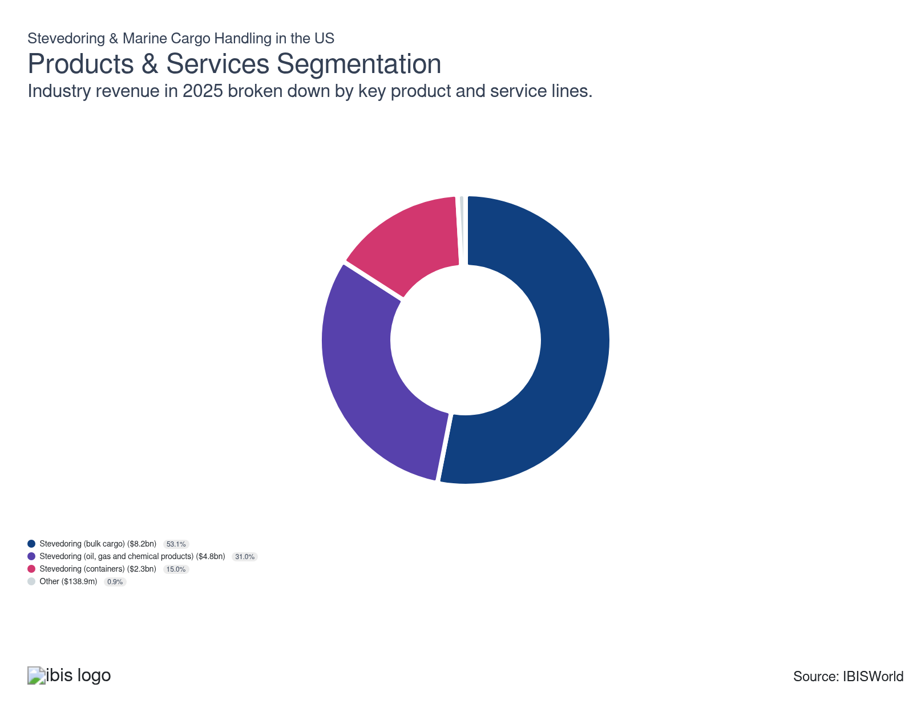

How are the industry’s products and services performing?

Commodity volatility and containerization pressure the bulk cargo segment
- Bulk cargo stevedoring remains the most significant segment because it supports high-volume trade in raw materials such as coal, grain, crude oil and chemicals. Stevedoring (bulk cargo) involves specialized services for handling and transporting bulk commodities via commercial vessels of various sizes. Small, handy-size carriers handle minor bulk loads on regional trade routes, while major commodities like iron ore and coal are moved via Capesize vessels along long-haul routes.
- Bulk operations require extensive infrastructure, such as silos, conveyors and liquid pipelines. Labor for loading, trimming and blending materials also makes them asset- and labor-intensive.​ Bulk cargo transport remained strong amid resilient consumer spending and residential construction activity. While tightened monetary policy dampened growth and weakened specific sectors within construction, broader economic activity supported demand for bulk cargo.
- However, bulk cargo stevedoring declined slightly as coal exports and domestic coal use fell as utilities shifted toward natural gas and renewables. According to the BTS, corn throughput also decreased by 30 million tons between 2021 and 2022, also contributing to the decline.
- Global commodity volatility, including fluctuating prices for oil, grain and metals, has reduced export volumes in certain years and increased reliance on storage and value-added processing rather than direct shipment. Trade diversification and containerization have also restructured cargo flows, with more US exports moving in containers to support e-commerce and manufactured goods, displacing some traditional breakbulk and bulk shipments.​

Volatility in the energy markets supports oil, gas and chemicals
- Oil and gas services remain the second-largest market for stevedores, despite a small drop in the product segment. The US continues to be the largest producer of oil in the world and one of the top exporters of oil, gas and chemicals. As the initial spike of oil and LNG exports moderated, global markets adjusted to the new trade dynamic and countries like China and India elevated their energy exports.
- This segment benefited from higher volumes of ammonia, methanol, fertilizers and industrial solvents handled through bulk terminals and chemical export piers. New refineries and petrochemical expansions in Texas and Louisiana, fueled by low-cost natural gas and strong international demand, sustained high throughput of specialized cargo such as reactors, catalysts and fractionation units.
- Loading and unloading oil, gas and other chemicals on tankers requires sophisticated equipment that only a few stevedores can provide. The war in Ukraine prompted rising energy exports as the US stepped in to fill the supply gap after sanctions on Russia prevented Europe from importing natural gas from Russian-based pipelines.
- Energy infrastructure investment, both public and private, further propelled stevedoring demand tied to oil and gas facilities since many terminals require continuous construction, maintenance and component shipments.

Nearshoring, elevated consumer spending and innovation stabilize the containers segment
- Container stevedoring involves loading and unloading standardized cargo containers from ships using cranes for stacking and lashing for securing. These containers typically measure eight feet in width, eight feet in height and 20.0 or 40.0 feet in depth. They transport various goods, including consumer products, automobiles and organic materials.
- Rising consumer spending is supporting the product segment's performance. Demand for imported consumer goods and industrial inputs offsets slower export growth. The containerization of traditional cargoes, such as auto parts, machinery, and some agricultural products, continues to strengthen the container segment's resilience relative to bulk or breakbulk trade. Still, tightened monetary policy at the beginning of the period resulted in subdued trade value performance, pressuring growth.
- Technological modernization and automation have improved container terminal efficiency. Upgrades such as automated stacking cranes, remote-controlled gantry cranes and digital logistics platforms have optimized vessel turnaround times, enabling ports to manage fluctuating volumes while keeping service reliable. This operational maturity reduces the sensitivity of container throughput to short-term economic slowdowns.
- The global supply-chain reshoring trend has further stabilized container operations. Nearshoring manufacturing to Mexico and Central America continues to strengthen north–south container flows and reduce dependency on longer Asian routes, helping preserve container handling volumes during global trade disruptions.

Rising credit card debt and higher interest rates pressured the other segment
- Other services encompass varying support services, such as tugboat operations, ferrying, maintenance and repair services, logistics management and short-distance goods transportation.
- Other services focus on services offered for passenger vessels like cruise ships and ferries, including transporting luggage and cargo. Economic conditions heavily impact the sector. Consumers tend to elevate their discretionary spending when the economy improves, benefiting recreational activities like cruises.
- Tightened monetary policy and rising credit card debt deterred consumers from leisure spending, pressuring the product segment at the beginning of the period. If the Fed continues to lower interest rates, this segment may expand.

What are innovations in industry products and services?

Automation drives revenue growth
- Innovative technologies like robotic cranes, automated guided vehicles and drones designed for cargo inspection significantly enhance efficiency. Rising insight into logistics handling allows stevedores to improve the speed with which they handle incoming shipments.
- Rising automation drives on-site productivity and reduces health hazards. Progress in analyzing shipments and deploying machinery to unload cargo improves vessel turnover, leading to higher revenue growth.

What products or services do successful businesses offer?
Allocate products and/or services to areas of greatest need
Efficient resource allocation helps promptly meet high-demand areas, maximizing operational efficiency and customer satisfaction. The strategic approach enables better resource planning and optimizes service delivery.
Secure access to well-established brand names
Partnering with recognized brands boosts credibility and attracts more clients. Established brand associations can enhance trust and open new business opportunities, fostering long-term partnerships and market growth.

Major Markets
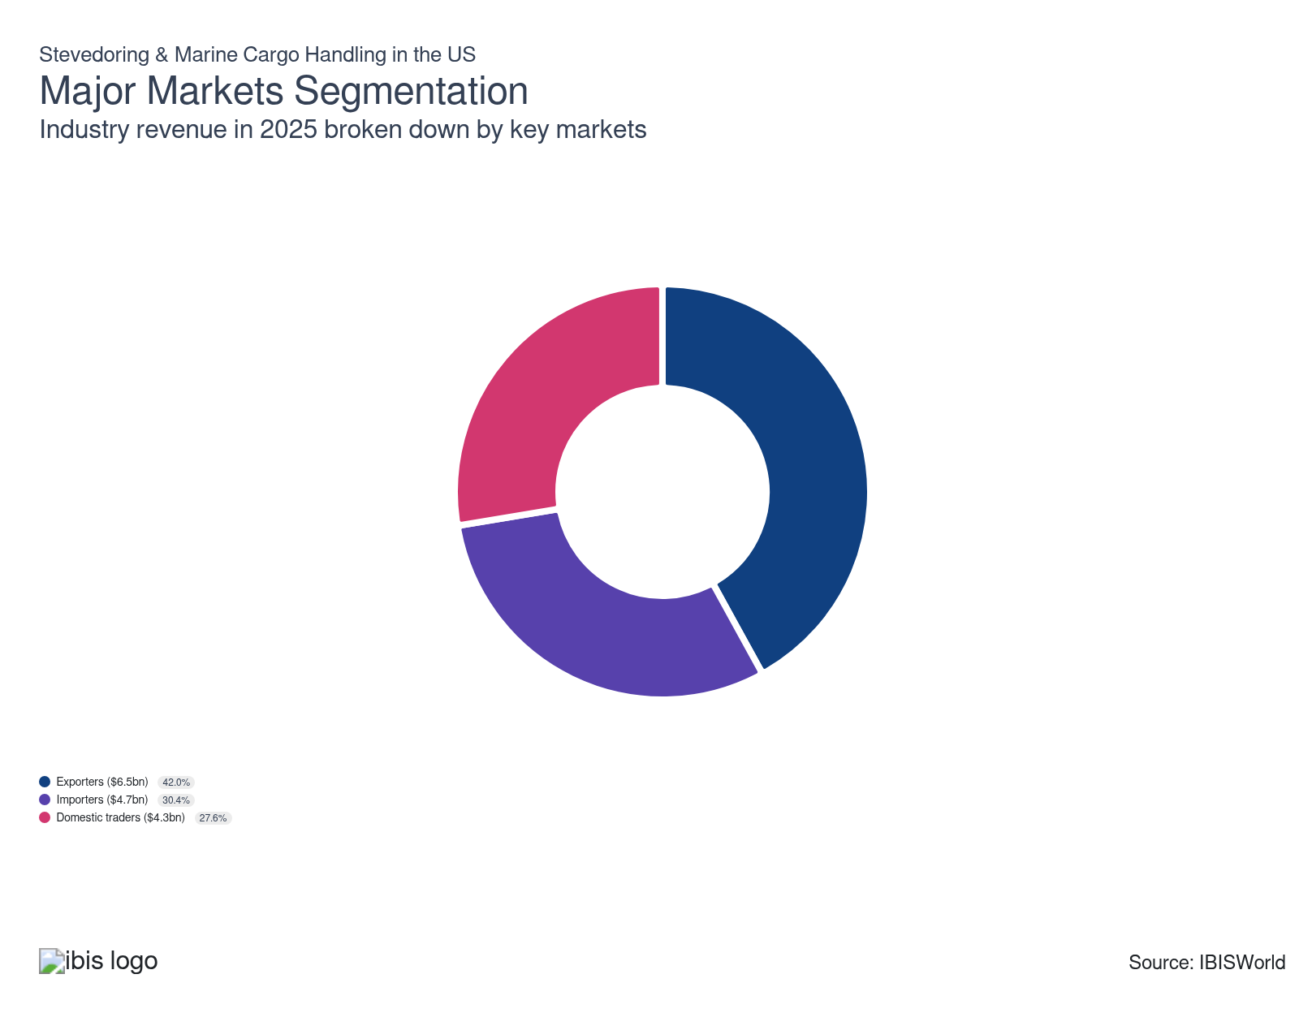

What’s influencing demand from the industry’s markets?

Energy production determines the level of export activity
- Exporters comprise the largest market for the U.S. stevedoring and marine cargo handling industry because exports generate higher tonnage, greater handling complexity and consistent demand across energy, agriculture and manufacturing sectors. According to the Bureau of Transportation Statistics, export shipments accounted for roughly 35.5% of total US waterborne trade tonnage in 2024, with export cargo typically involving bulk commodities such as oil, LNG, chemicals, soybeans, corn and industrial machinery, which require stevedoring and marine cargo handling.
- The export market performs well in 2025 despite trade friction and soft global growth. US goods exports totaled $176.1 billion in August 2025, down slightly from August 2024 and July 2025 as industrial and energy shipments eased seasonally. According to the USDA Economic Research Service, agricultural exports remain strong, driven by robust demand for US grains, oilseeds and protein products from Asia and Africa.​ If reciprocal tariffs climb, export markets may see more pressure in the later months of 2025.
- Throughout the current period, geopolitical tensions, such as the war in Ukraine, have disrupted the global energy market, allowing the US to step in and fill the supply gap by supplying crude oil and natural gas to European countries. Rising energy production has also elevated export activity as extraction sites and refiners capitalize on higher energy prices.
- Global markets are still adjusting to the disruptions in energy supply, which resulted in lower energy prices throughout the second half of the current period. Moderating oil prices resulted in less extraction activity and reduced growth in barrels exported. If demand for domestic petroleum decreases over the next five years, this export market will see pressure.

Import volumes fluctuate under tariff pressure but remain key demand driver
- Importers are corporations that bring goods into the US, engaging with stevedoring and marine cargo handling to assist with offloading cargo from ships, temporarily storing certain items and arranging for the distribution of products within the country via trains and trucks.
- As of July 2025, total US goods imports were valued $283.3 billion, up $18.4 billion from the prior month, reflecting higher inbound shipments of industrial materials, capital goods and nonmonetary gold, according to the Bureau of Economic Analysis. Consumer goods, particularly electronics, furniture and auto parts, remain dominant cargo categories. However, importers faced rising costs as tariffs lifted effective import tax rates during early 2025, reducing activity from China and increasing sourcing from Mexico and Southeast Asia.​
- After frontloading on foreign goods before tariff implementation, US companies will likely reduce import volumes in the third and fourth quarters of 2025. If trade networks adapt to tariffs, stevedoring and marine cargo handling will benefit from the diversification of global supply chains.

Inland and coastal trade sustain steady domestic demand for stevedoring and marine cargo handling
- Domestic traders include the domestic manufacturing sector and other businesses and vessels that move marine cargo through the nation's lakes, coastlines and inland waterways. According to the Bureau of Transportation Statistics, the top 150 US ports managed 1.86 billion short tons of total cargo in 2022, with a large share tied to domestic waterborne transport through the Mississippi River system, Gulf Intracoastal Waterway and Great Lakes routes. These channels link the country's agricultural, chemical and construction industries, providing cost efficiency at about a fraction of the freight cost for road and rail transport.
- However, geopolitical tensions early in the period caused ports to become congested. Domestic manufacturers opted for distribution via railroads and trucks to circumvent the prolonged delays caused by the supply chain disruptions that plagued the ports, particularly as goods from Asia flooded the ports of Los Angeles and Long Beach.
- Infrastructure investments through the Infrastructure Investment and Jobs Act (IIJA) are expanding dredging, lock maintenance and coastal terminal upgrades, directly enhancing productivity for cargo such as refined fuels, building materials and manufactured components that move between inland and coastal facilities. If support under the IIJA ends in 2026, this segment will be less likely to expand.

International Trade

Some industries don't directly import or export goods. See reports at the manufacturing level for international trade data on relevant products.

5. Geographic Breakdown
https://my.ibisworld.com/us/en/industry/48832/geographic-breakdown

Key Takeaways
- The Southeast has the highest number of establishments because of its strategic location with numerous ports and waterways. The features drive the need for extensive logistics infrastructure, particularly for shipping and distribution companies along the Mississippi River.
- California's vast coastline makes the West the largest revenue generator in the cargo-handling industry. The region's natural harbors and major ports like Long Beach and Los Angeles facilitate extensive trade, particularly with Asia. The Port of Los Angeles reported record activity in mid-2025.
- Texas's energy exports significantly support the Southwest's establishment growth. Texas' strategic port locations and extensive oil and gas industry require efficient stevedoring services to manage substantial marine cargo volumes.

Business Locations
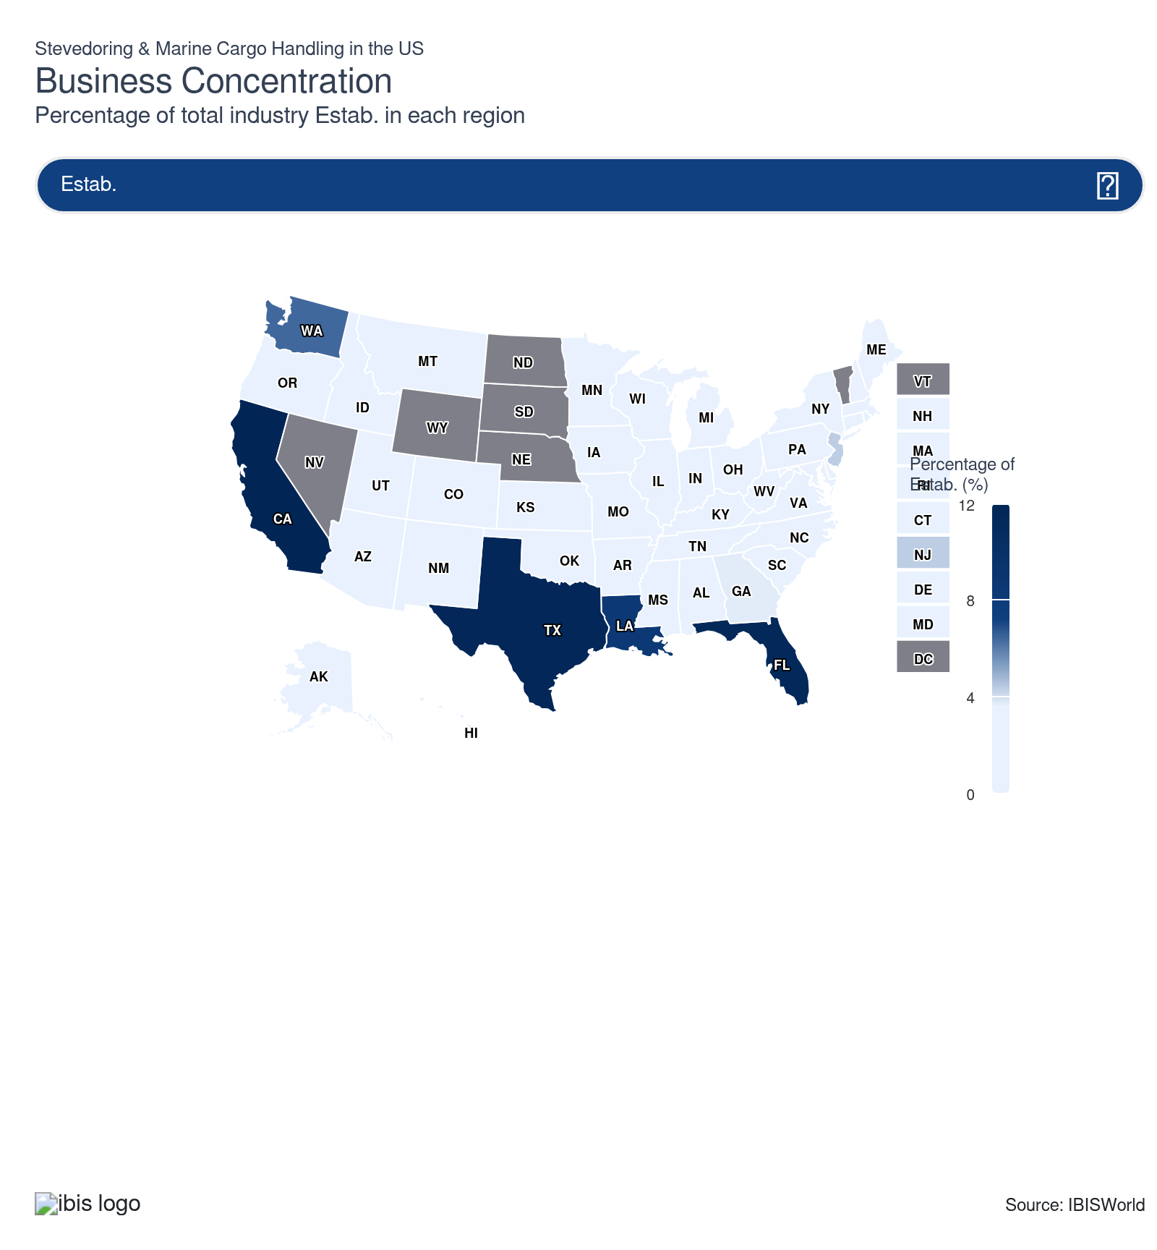
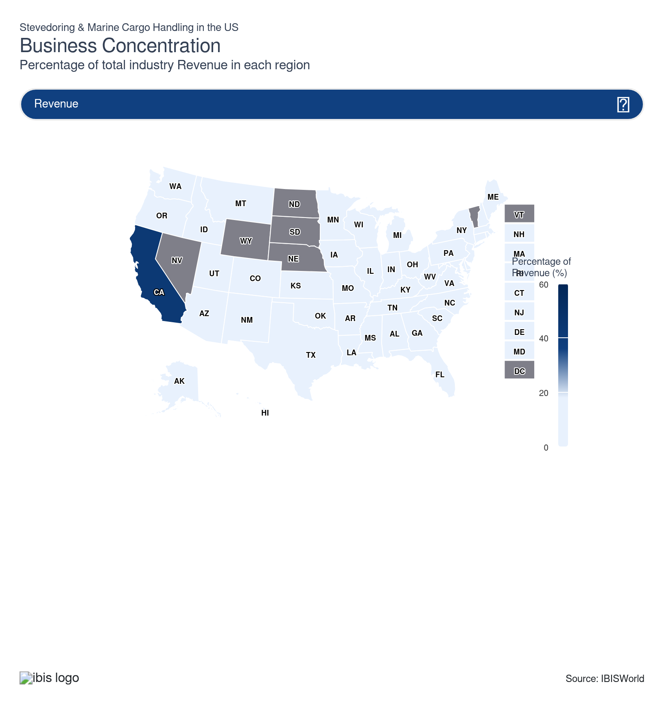
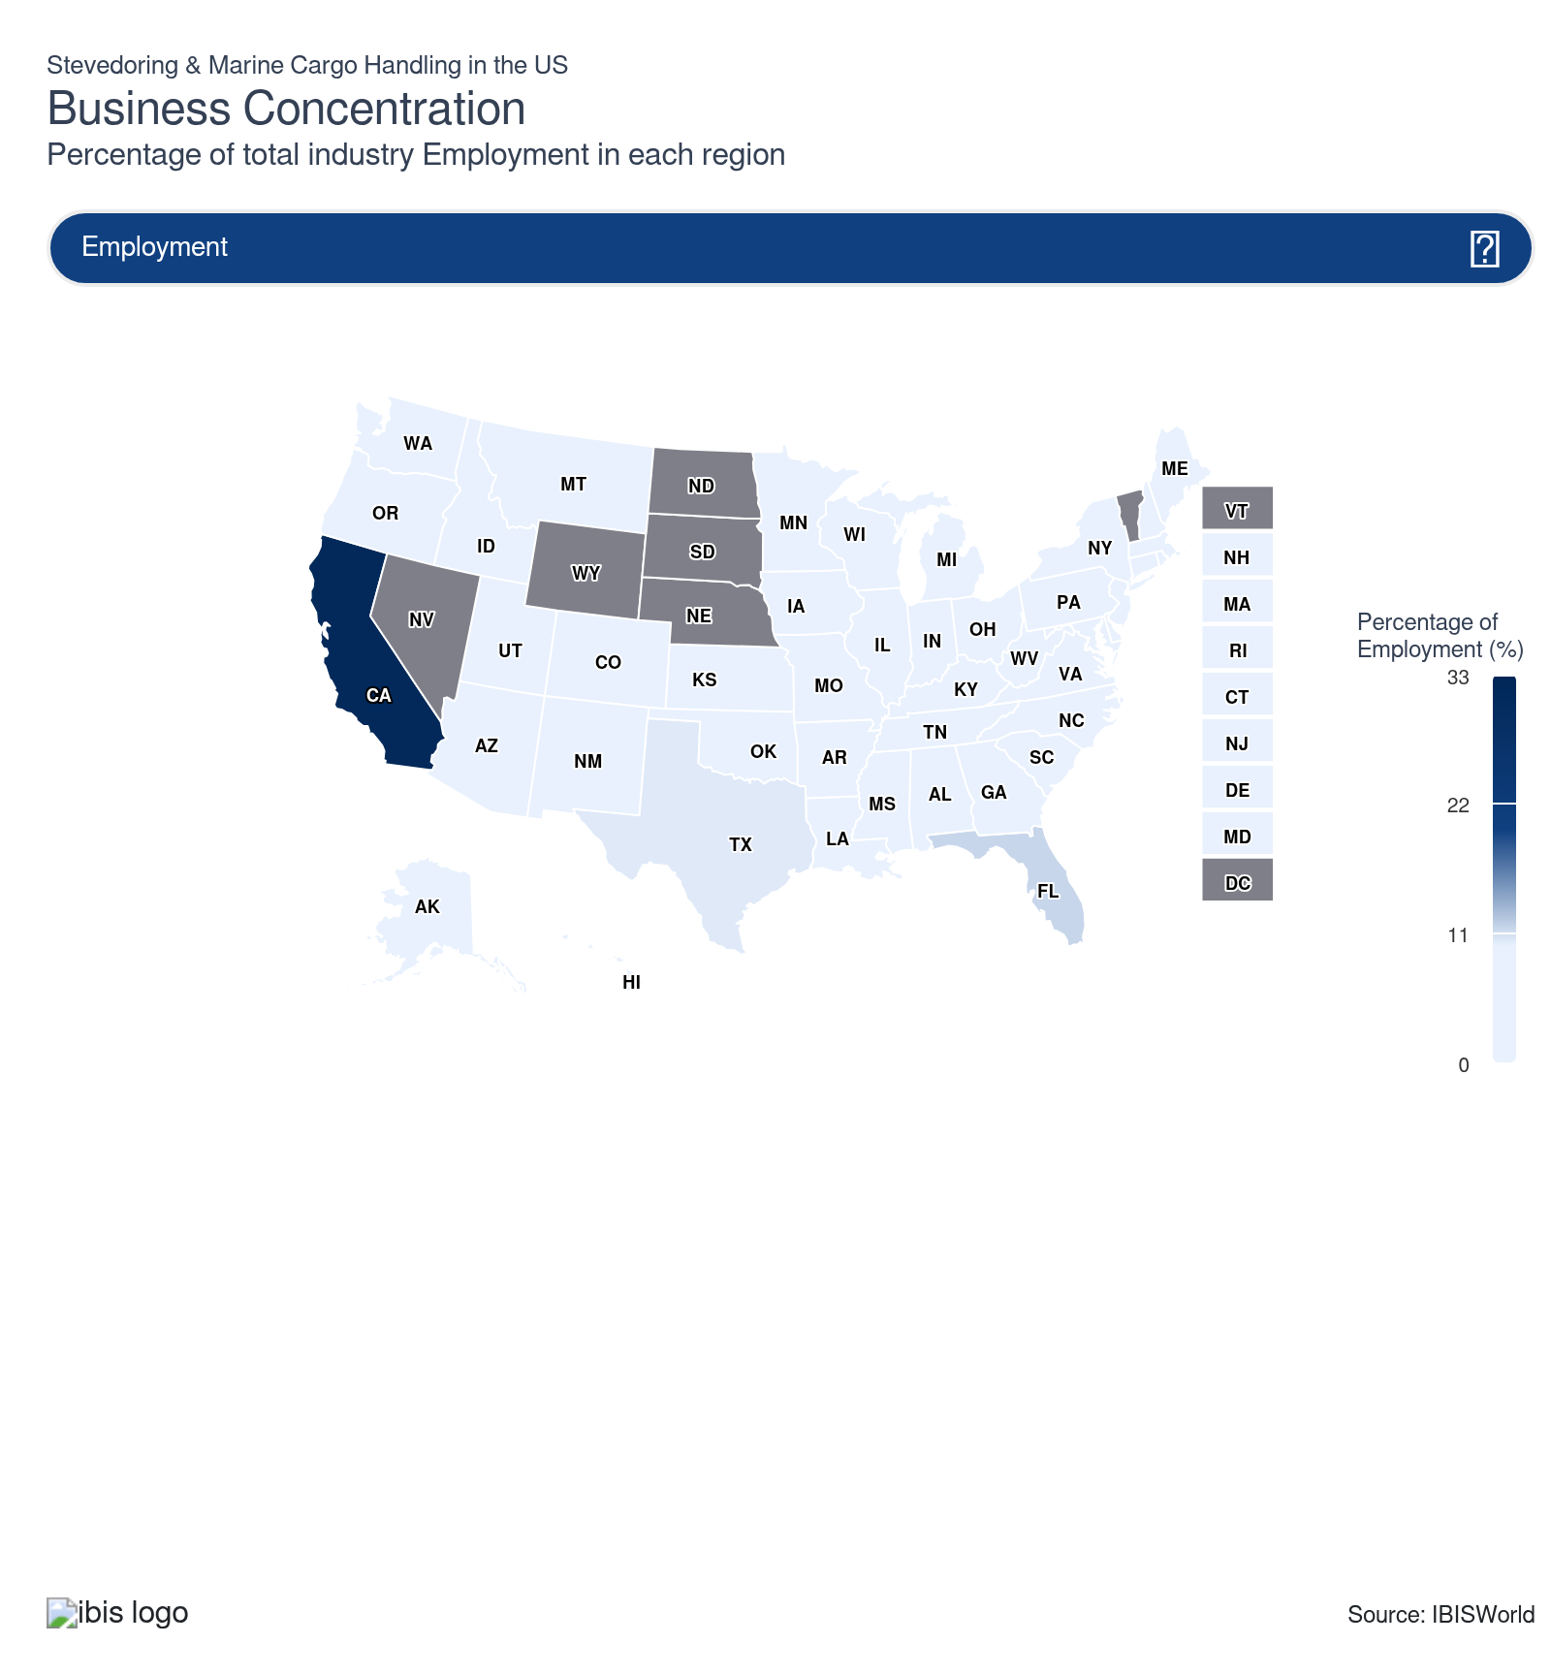
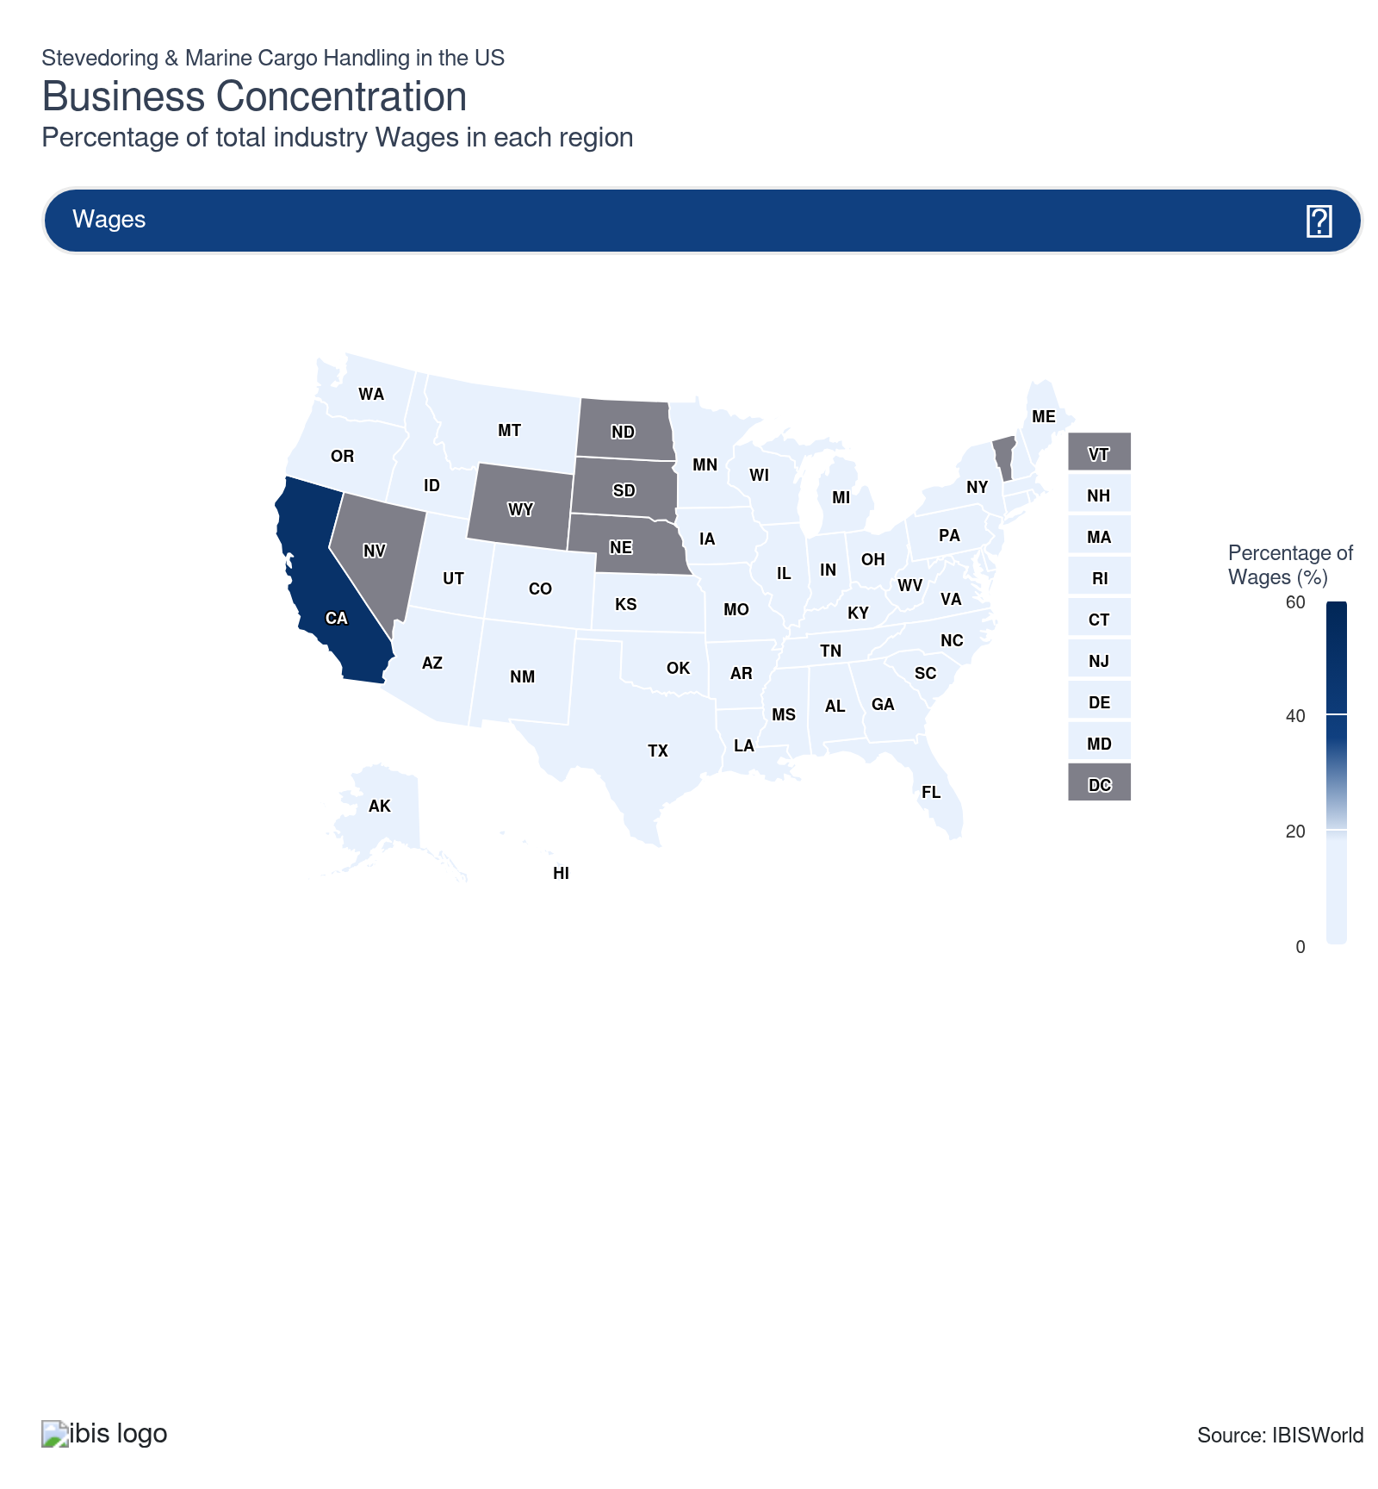
State | Estab.  Units | Estab.  % | Revenue  $m | Revenue  % | Wages  $m | Wages  % | Employment  Units | Employment  % | Population  %
California | 59 | 12.1 | 6,598.0 | 42.7 | 3,130.8 | 49.2 | 21,407 | 31.7 | 11.5
New Jersey | 21 | 4.3 | 1,567.9 | 10.2 | 755.2 | 11.9 | 4,228 | 6.3 | 2.8
Texas | 57 | 11.7 | 1,109.9 | 7.2 | 344.0 | 5.4 | 6,978 | 10.3 | 9.3
Florida | 56 | 11.5 | 885.2 | 5.7 | 269.5 | 4.2 | 7,698 | 11.4 | 7.0
Washington | 31 | 6.4 | 1,011.1 | 6.5 | 598.0 | 9.4 | 4,416 | 6.5 | 2.3
Louisiana | 41 | 8.4 | 760.7 | 4.9 | 181.0 | 2.8 | 3,267 | 4.8 | 1.3
Georgia | 18 | 3.7 | 498.9 | 3.2 | 197.7 | 3.1 | 4,987 | 7.4 | 3.3
Arizona | 4 | 0.8 | 588.0 | 3.8 | 102.4 | 1.6 | 591 | 0.9 | 2.2
Illinois | 16 | 3.3 | 87.1 | 0.6 | 23.3 | 0.4 | 251 | 0.4 | 3.7
Alabama | 16 | 3.3 | 254.9 | 1.7 | 61.3 | 1.0 | 826 | 1.2 | 1.5
South Carolina | 11 | 2.3 | 420.6 | 2.7 | 115.7 | 1.8 | 2,558 | 3.8 | 1.6
Maryland | 13 | 2.7 | 340.7 | 2.2 | 122.7 | 1.9 | 1,819 | 2.7 | 1.8
Ohio | 14 | 2.9 | 63.0 | 0.4 | 18.3 | 0.3 | 187 | 0.3 | 3.5
Pennsylvania | 11 | 2.3 | 206.3 | 1.3 | 95.4 | 1.5 | 1,408 | 2.1 | 3.8
Virginia | 9 | 1.9 | 151.9 | 1.0 | 91.2 | 1.4 | 1,129 | 1.7 | 2.6
Hawaii | 11 | 2.3 | 243.3 | 1.6 | 96.0 | 1.5 | 880 | 1.3 | 0.4
North Carolina | 11 | 2.3 | 86.3 | 0.6 | 34.2 | 0.5 | 660 | 1.0 | 3.3
New York | 10 | 2.1 | 218.8 | 1.4 | 95.3 | 1.5 | 692 | 1.0 | 5.8
Oregon | 9 | 1.9 | 213.9 | 1.4 | 61.2 | 1.0 | 739 | 1.1 | 1.2
Alaska | 9 | 1.9 | 71.0 | 0.5 | 34.0 | 0.5 | 446 | 0.7 | 0.2
Delaware | 4 | 0.8 | 21.0 | 0.1 | 8.7 | 0.1 | 579 | 0.9 | 0.3
Mississippi | 7 | 1.4 | 48.2 | 0.3 | 14.0 | 0.2 | 426 | 0.6 | 0.9
Kentucky | 6 | 1.2 | 6.6 | 0.0 | 2.6 | 0.0 | 45 | 0.1 | 1.3
Oklahoma | 6 | 1.2 | 25.3 | 0.2 | 5.7 | 0.1 | 104 | 0.2 | 1.2
Connecticut | 4 | 0.8 | 29.8 | 0.2 | 2.2 | 0.0 | 19 | 0.0 | 1.1
Arkansas | 4 | 0.8 | 26.0 | 0.2 | 2.8 | 0.0 | 69 | 0.1 | 0.9
Indiana | 5 | 1.0 | 19.4 | 0.1 | 6.6 | 0.1 | 82 | 0.1 | 2.0
Rhode Island | 4 | 0.8 | 15.1 | 0.1 | 6.9 | 0.1 | 97 | 0.1 | 0.3
Michigan | 4 | 0.8 | 8.1 | 0.1 | 0.5 | 0.0 | 8 | 0.0 | 3.0
Wisconsin | 4 | 0.8 | 8.1 | 0.1 | 2.0 | 0.0 | 28 | 0.0 | 1.7
Maine | 4 | 0.8 | 4.5 | 0.0 | 2.4 | 0.0 | 32 | 0.0 | 0.4
Minnesota | 4 | 0.8 | 4.2 | 0.0 | 1.1 | 0.0 | 13 | 0.0 | 1.7
Missouri | 4 | 0.8 | 17.5 | 0.1 | 6.5 | 0.1 | 58 | 0.1 | 1.8
Iowa | 4 | 0.8 | 5.3 | 0.0 | 0.7 | 0.0 | 19 | 0.0 | 1.0
West Virginia | 4 | 0.8 | 2.2 | 0.0 | 0.8 | 0.0 | 22 | 0.0 | 0.5
Tennessee | 4 | 0.8 | 12.2 | 0.1 | 2.1 | 0.0 | 32 | 0.0 | 2.1
Colorado | 2 | 0.4 | 11.1 | 0.1 | 3.6 | 0.1 | 53 | 0.1 | 1.8
Kansas | 2 | 0.4 | 10.1 | 0.1 | 2.9 | 0.0 | 57 | 0.1 | 0.9
New Hampshire | 2 | 0.4 | 9.2 | 0.1 | 3.2 | 0.1 | 50 | 0.1 | 0.4
Utah | 2 | 0.4 | 10.4 | 0.1 | 3.0 | 0.0 | 56 | 0.1 | 1.0
Idaho | 2 | 0.4 | 5.7 | 0.0 | 1.5 | 0.0 | 40 | 0.1 | 0.6
New Mexico | 2 | 0.4 | 5.8 | 0.0 | 1.5 | 0.0 | 40 | 0.1 | 0.6
Massachusetts | 3 | 0.6 | 2.4 | 0.0 | 2.0 | 0.0 | 28 | 0.0 | 2.1
Montana | 2 | 0.4 | 4.4 | 0.0 | 1.1 | 0.0 | 30 | 0.0 | 0.3

Where are industry businesses located?

Favorable tax rate, incentive programs, climate and intermodal infrastructure make the Southeast essential
- Because of its strategic location with 36.3% of establishments, the Southeast has become a significant market for stevedoring and marine cargo handling. Shipping and distribution companies along the Mississippi River require extensive logistics infrastructure, driving the usage of stevedores.
- States like Louisiana and Florida have become pivotal centers for incumbent and new enterprises amid trade with Latin America through the Gulf of Mexico. The tourism industry further propels new establishments, as Florida remains one of the top destinations for cruise lines. The states' competitive cost environment, characterized by favorable tax rates and robust incentive programs, creates ideal conditions for stevedoring companies and terminal operators to maintain profitability while investing in equipment and technology upgrades.
- Weather conditions in the Southeast provide year-round operational advantages that minimize disruptions common in northern ports during winter. The region's favorable climate enables consistent transportation capabilities without the severe weather-related delays that impact northeastern logistics.
- This climate advantage, combined with the region's network of major highways, including I-75, I-40 and I-85 and access to Atlantic coastlines through ports in Savannah, Charleston and Jacksonville, positions Southeast stevedoring operations to maintain reliable schedules and predictable turnaround times. The reduced risk of weather-related cargo damage and equipment downtime translates into lower insurance costs and asset utilization for terminal operators.

Los Angeles and Long Beach ports drive demand for stevedoring despite tariff pressures
- California's vast coastline makes it an attractive location for cargo-handling businesses. Numerous natural harbors and bays in the state facilitate trade, while the region boasts the Ports of Long Beach and Los Angeles, two of the nation's largest in terms of cargo volume.
- The West facilitates trade coming from Asia into the US. The region specializes in handling container and bulk cargo, as e-commerce and consumer goods fuel the need for imports. West Coast ports face intensifying competition from Atlantic and Gulf Coast facilities that have established rail service to Midwest markets traditionally served via California intermodal routes. 2025 tariffs have also limited imports, with reported declines at the Port of Los Angeles in August and September 2025.
- The California Air Resources Board (CARB) has established specific dates, triggers and thresholds for electric truck requirements. Since these trucks take longer to charge, stevedoring revenue may be under pressure because of delays. Environmental regulations can hike costs in the short term, but position West Coast ports as well-prepared for clean energy future requirements and potential federal emissions standards.

Texas dominates through significant energy exports and strategic mexico trade corridor positioning
- The Southwest, particularly Texas, features 14.0% of stevedoring establishments because of its strategic port locations, such as Houston, Galveston and Corpus Christi. These are vital for handling substantial marine cargo volumes traveling through the Gulf of Mexico.
- The Southwest region benefits from exceptional raw materials access and manufacturing infrastructure, creating continuous demand for stevedoring services across diverse industrial sectors. Texas is the nation's largest state exporter, with cargoes moving through its ports, including petrochemicals, new and used automobiles, industrial machinery, retail electronics, agricultural products and steel products.
- Texas's extensive oil and gas industry also requires efficient stevedoring services for exporting petroleum products and importing equipment for drilling and extraction sites. The state's well-developed transportation infrastructure supports cargo distribution, fostering establishment growth.

New York and New Jersey emerge as the East Coast's dominant container gateway
- With around 10.0% of establishments located in NY and NJ, the East Coast remains an essential location for stevedoring and marine cargo handling. The Port Authority's commitment to supporting stevedoring infrastructure includes significant upgrades to the road network serving marine terminals, PATH commuter rail modernization and rehabilitation projects designed to accommodate the increasing size of container vessels navigating global trade routes.​
- Recent federal investments further strengthen this advantage, exemplified by the EPA's historic $400.0 million Clean Ports Program funding announced in October 2024, which will transform port operations through zero-emission equipment deployment, charging infrastructure, and vessel shore power capabilities.
- Weather patterns in the Northeast present operational challenges that stevedoring companies must actively manage through advanced planning and infrastructure preparedness. Logistics providers in the Northeast have responded by implementing comprehensive weather monitoring systems, flexible routing protocols using advanced technology and warehouse facilities designed to protect goods from flooding and temperature extremes.
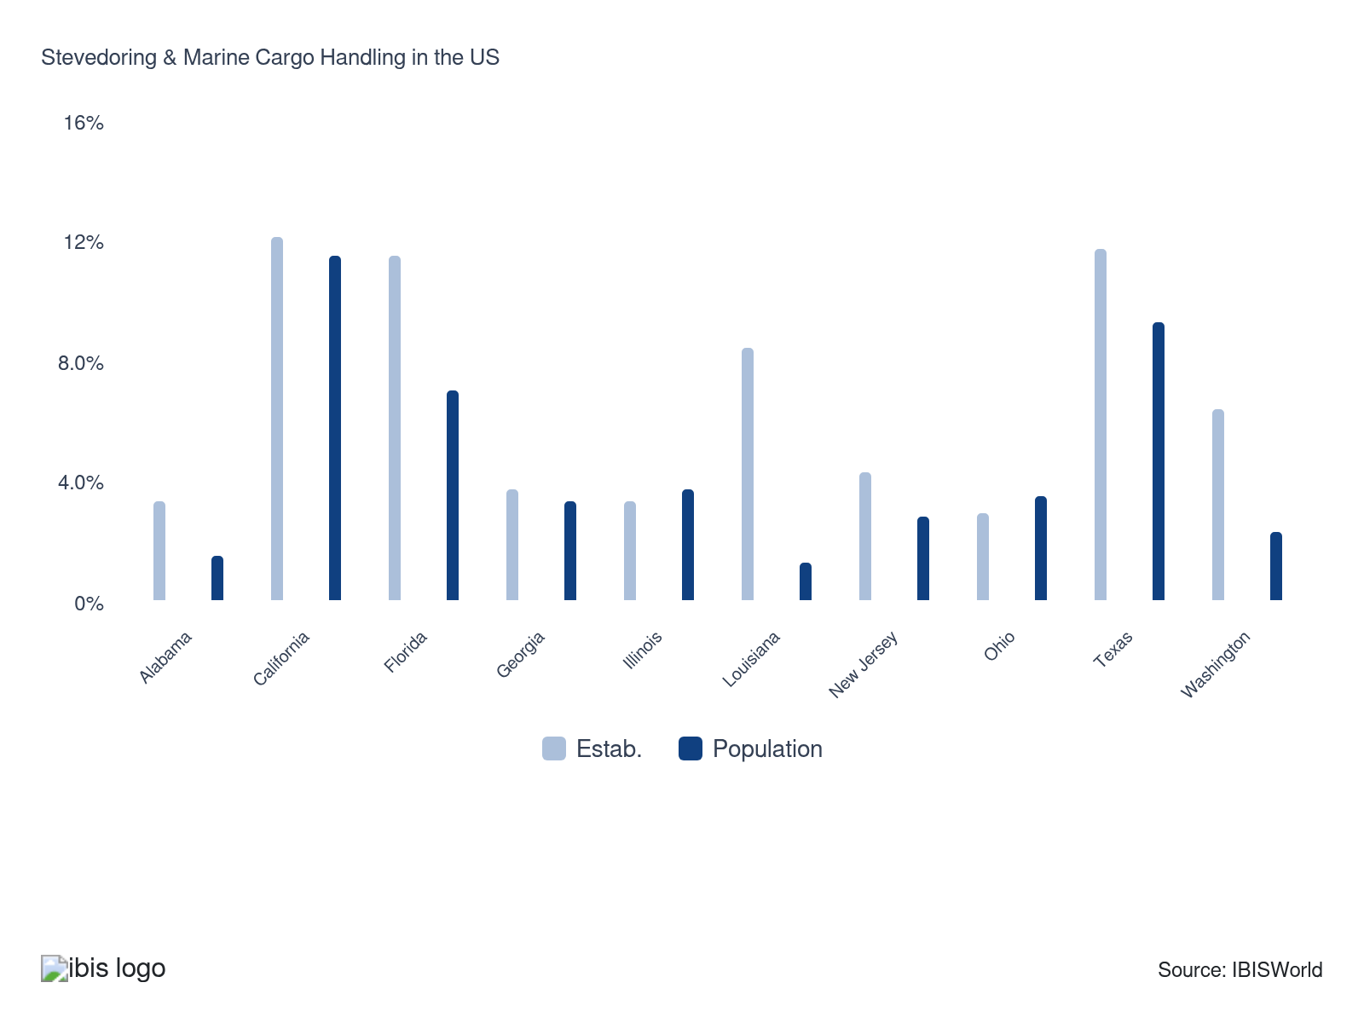

How do businesses use location to their advantage?
Operate in a location that is close to key markets
Being near key markets reduces transportation time and costs, enhancing service efficiency and ensuring timely delivery. The proximity makes the operation more attractive to clients seeking reliable and swift logistics services.
Operate in a location that is close to transport
Positioned near major transportation hubs like ports, railways and highways, stevedoring operations can seamlessly transfer cargo, minimizing delays and optimizing the supply chain. The strategic location is crucial for effective and efficient cargo handling.

6. Competitive Forces
https://my.ibisworld.com/us/en/industry/48832/competitive-forces

Key Takeaways
- The congestion at major ports led to gains for small establishments. As goods were rerouted to underutilized ports, new entrants and lower-scale stevedores saw rising business and revenue growth.
- Incumbent enterprises dominate major ports because of their capacity to handle large cargo volumes. The established companies offer value-added services and logistics that smaller firms cannot match because of high capital requirements.
- As supply chain disruptions ease, incumbent enterprises may regain market share. The return to pre-pandemic commerce patterns will likely favor major companies over smaller competitors who benefited from the temporary rerouting of goods.
- The adoption of automation and digital planning tools improves yard productivity and safety. Companies that adopt automation with minimal impact on their cost structures will likely be the most competitive.​

Concentration
Low
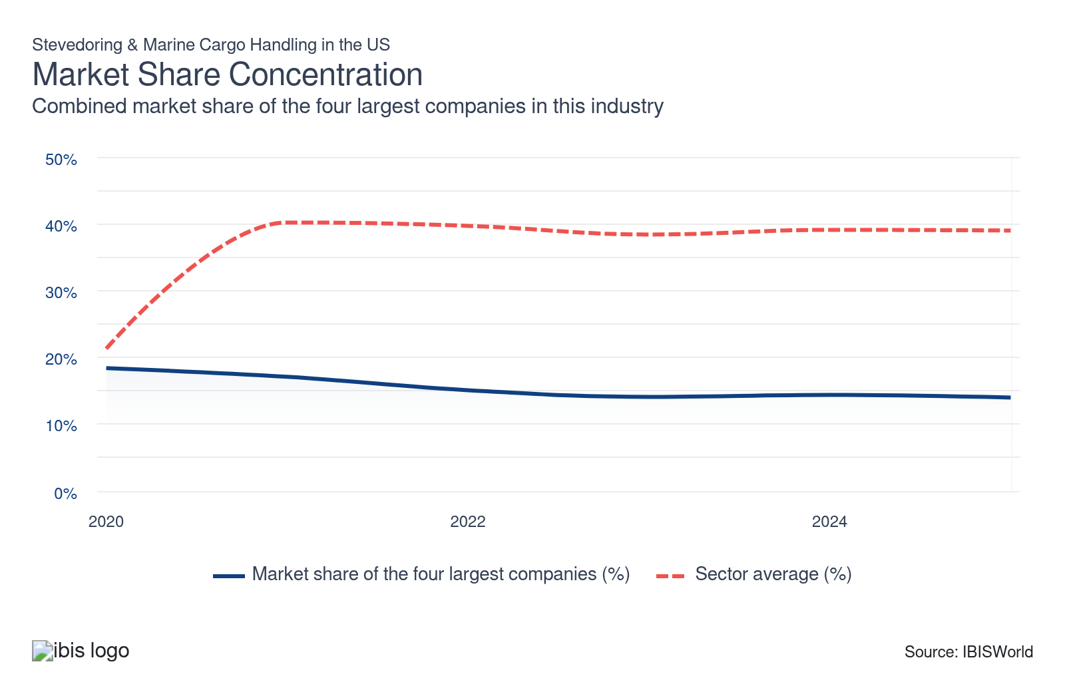

What impacts the industry’s market share concentration?

Incumbent enterprises dominate major ports
- The concentration varies heavily by location and the number of parcels a port handles. Major companies tend to secure contracts with ports carrying the most significant volume of products, particularly in high-traffic areas like the West Coast, which is the primary destination for goods from Asia.
- Established enterprises utilize value-added services and the capability to handle a wide range of cargo to deliver the most optimal logistical solutions that small companies can't replicate because of high capital requirements.

Mixed public-private ownership, equipment immobility and port-specific regulations keep stevedoring fragmented
- While some ports operate under full public service models with government-employed stevedores, others use landlord models where private operators lease terminals and others have corporatized or fully privatized structures. These different governance approaches generate varying cost structures, regulatory requirements and operational standards that prevent industry-wide consolidation and favor specialized regional operators.
- Equipment immobility and port-specific investments require stevedores to maintain separate facilities and machinery at each location they serve, preventing economies of scale across multiple ports. Cranes, yard equipment and handling systems cannot be quickly relocated between ports, forcing operators to make location-specific capital commitments that favor smaller, focused operations over large multi-port networks.
- Compliance and regulatory complexity vary significantly across port authorities, cargo types and international versus domestic operations, creating specialized knowledge requirements that favor local operators with established relationships and expertise in specific regulatory environments.

Congestion in major ports benefited small establishments
- Supply chain disruptions caused congestion at major ports, resulting in goods being rerouted to other locations as merchants looked for alternatives to deliver their cargo.
- As cargo moved to previously underutilized ports, new entrants and lower-scale stevedores secured business and saw rising revenue growth from 2020 to 2022. When supply chains stabilized and commerce returned to pre-pandemic patterns, the incumbent enterprises benefited, regaining some of the lost market share in 2024.

Labor unions ensure high fragmentation
- Labor union structure and local hiring halls create regional pockets of specialized workers tied to specific ports, limiting labor mobility and encouraging locally-based stevedoring operations. The International Longshore and Warehouse Union (ILWU) maintains local autonomy for strike action and contract negotiation, with some Pacific Northwest locals remaining independent for decades before joining broader union structures.​
- This local labor control prevents standardization across ports and sustains demand for region-specific stevedoring firms familiar with local work rules and hiring practices.

How do successful businesses handle concentration?
Optimize operating capacity
Efficiently using operating capacity ensures quick turnaround times for cargo handling, boosting productivity and reducing costs. Optimizing operations makes the company more competitive in a concentrated market.
Secure economies of scale
Handling large volumes of cargo can reduce per-unit operational costs. The economies of scale make services more cost-effective and attractive to clients, enhancing competitiveness in a concentrated market.

Barriers to Entry
High | Increasing

What challenges do potential industry entrants face?

Legal
- The regulations primarily relate to the discharge, treatment, storage, disposal, investigation and remediation of certain materials, substances and wastes. Operators must meet stringent OSHA cargo gear certification standards under 29 CFR Part 1919 for all shore-based material handling devices. All workers require Transportation Worker Identification Credential (TWIC) cards, which mandate comprehensive background checks. Insurance requirements include substantial marine cargo coverage and performance bonds, with companies needing to demonstrate financial capability before securing permits.

Start-Up Costs
- Cargo handling equipment represents the most significant initial investment, with shore-to-ship cranes, rubber-tired gantry cranes, reach stackers and automated guided vehicles requiring substantial capital expenditure. Beyond equipment, entrants must invest in port facility leases, storage infrastructure, maintenance facilities and IT systems for cargo tracking.

Differentiation
- Established operators maintain competitive advantages through long-term exclusive service contracts with major shipping lines and terminal concession agreements that restrict market access. Vertical integration between terminal operators and ocean carriers creates structural barriers, as integrated operators control container flows and can offer preferential service to affiliated shipping companies.

Labor Expenses
- Though the average company initially spends a significant amount on machinery, including cranes, vehicles and tracking software, the labor component of stevedoring operations makes up the bulk of industry operation costs. Labor unions also create upward pressure on wages.

How can potential entrants overcome barriers to entry?
Develop strong working relationships with lenders
Access to significant financial resources is crucial for initial capital investments and operational liquidity. Strong lender relationships ensure companies can secure funds and manage financial risks effectively.
Develop effective cost controls
Effective cost management is essential to remain competitive in the industry. By controlling operational expenses, businesses can offer competitive pricing and maintain profitability, even in a fluctuating market environment.

Substitutes
High | Steady

What are substitutes for industry services?

Railroad and Truck Transportation
- Rail and road are direct substitutes for water transportation and are often favored for the domestic distribution of bulky and low-value commodities. Railroad transportation facilitates cargo distribution from inland and coastal ports into warehouses and storage facilities.
- Railroads and trucks often assist port operations. While rail and trucks can replace stevedores in dry-land locations like warehousing and domestic manufacturing sectors, stevedores remain essential in handling imports, most of which remain tied to maritime transportation.

Air Transportation
- Goods can be flown to nearly any airport or runway in the US, which gives more flexibility to the scope of delivery. Still, because of its limited capacity and high cost, air transportation remains limited to transporting high-value, low-weight goods.
- Cargo vessels and oil tankers remain the primary transportation method for internationally traded goods because of the capacity and the economies of scale that can be developed with large volumes of parcels.

How do successful businesses compete with substitutes?
Invest in new technology to enhance operational efficiency and quality
Modernizing equipment and processes boosts efficiency and service quality, making it challenging for substitute services to compete on the same level of performance and reliability.
Produce high value-added goods
Offering value-added services like specialized cargo handling or logistics solutions differentiates the company from basic service providers, making it less vulnerable to substitution and more attractive to clients requiring specialized needs.

Buyer & Supplier Power
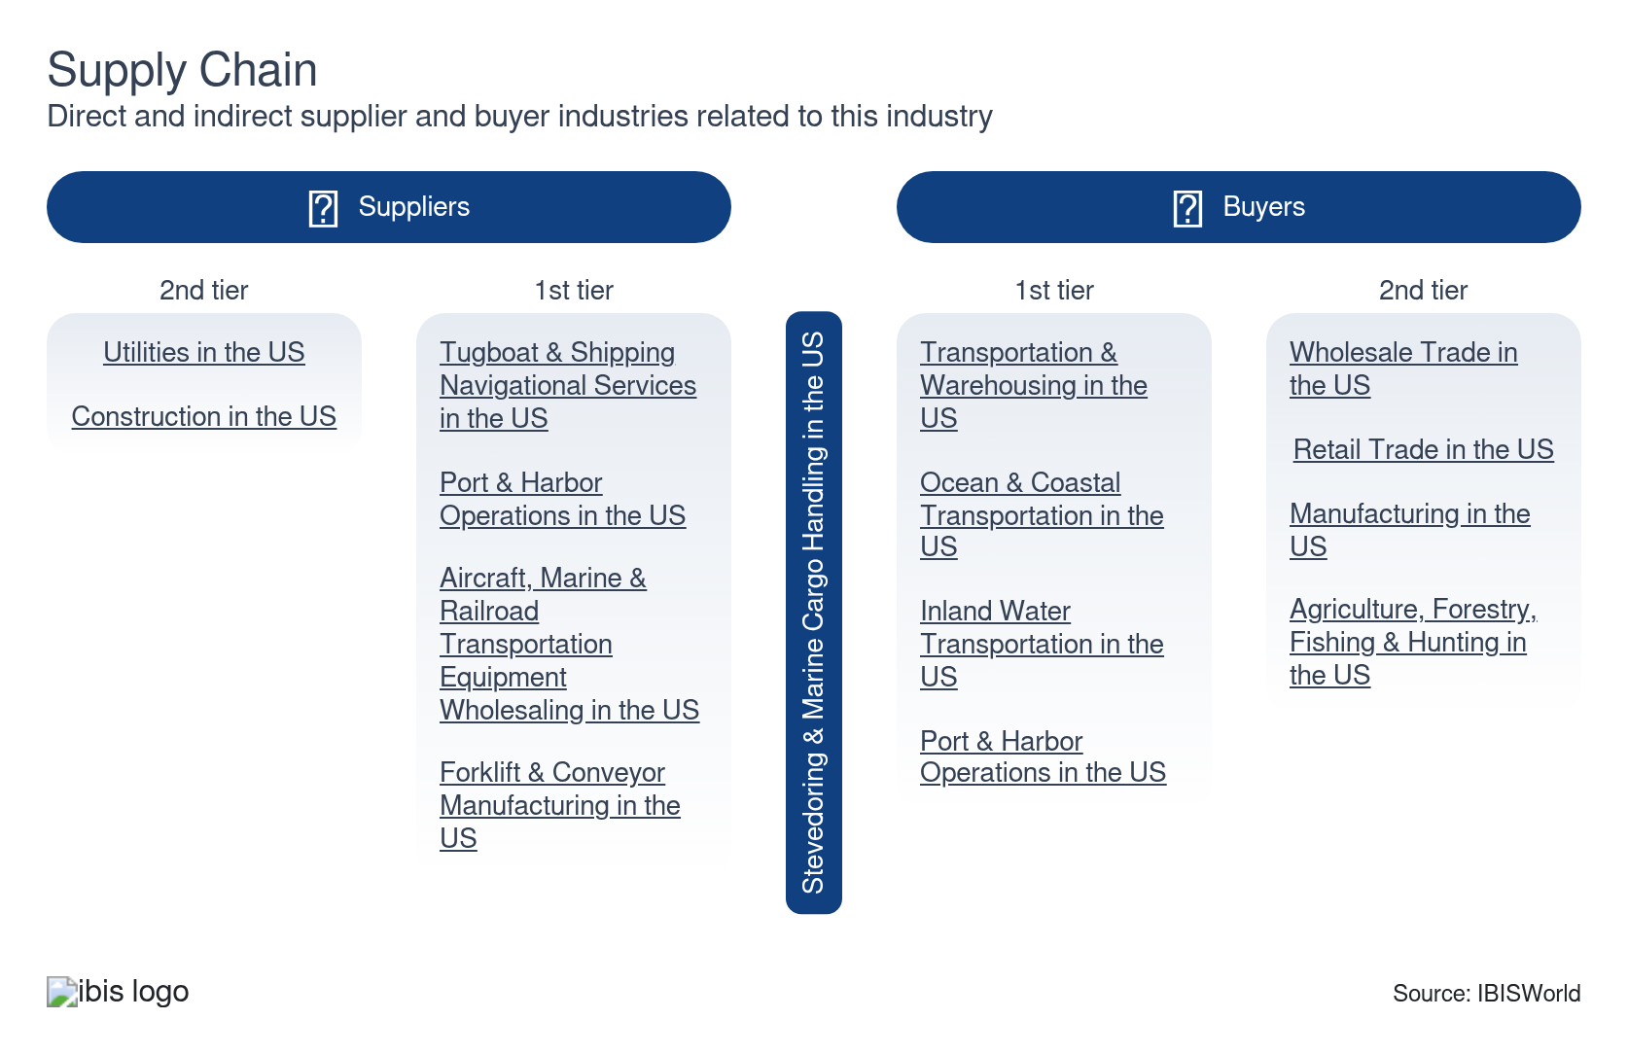

What power do buyers and suppliers have over the industry?

Buyers: Standardized services and low switching costs increase buyer power
High | Steady
- Price transparency and uniform service offerings reduce product differentiation among stevedores, making cargo handling a commodity service where buyers can easily compare offerings and negotiate based primarily on price. This standardization limits stevedores' ability to justify premium pricing through service differentiation.​
- Excess terminal capacity strengthens buyer power and lowers switching costs by creating competition among stevedores for vessel calls. This spare capacity environment gives shipping lines credible alternatives and the ability to shift business between terminals within the same port or to competing ports.​
- Concentrated shipping line ownership and alliances give buyers negotiating leverage. The consolidation of global container carriers has increased their collective bargaining power when negotiating terminal handling charges with stevedores.
- Buyers can also opt for different distribution methods that don't require going through ports and harbors. For high-value goods or during domestic distribution from manufacturing to warehousing facilities, rail or air transportation is more feasible. However, international businesses selling bulky cargo, containers or raw commodities depend on stevedores and don't have much negotiating power. Any cargo going through a port depends on third-party logistics support to unload the ships.

Suppliers: Specialized equipment, labor unions and limited upstream competition create supplier power
High | Steady
- Port equipment manufacturers operate in highly concentrated markets, giving suppliers substantial pricing power. Different cargo types, particularly commodities, require specific equipment to handle the loading and unloading process, making stevedores reliant on securing the latest machinery to stay competitive in the concentrated market.
- Suppliers with strong brand reputations, performance and up-to-date technological solutions hold more power. Incumbent enterprises can reduce costs through relationships with suppliers and well-established distribution networks, often leading to a higher profit margin.
- Labor unions maintain extraordinary bargaining strength as the dominant supply constraint for stevedoring operations. The International Longshoremen's Association (ILA) and International Longshore and Warehouse Union (ILWU) collectively represent nearly all US port workers and can shut down terminals immediately through strikes or work stoppages.
- Fuel suppliers also wield pricing power through commodity market dynamics and limited competition in marine diesel distribution. Marine diesel oil (MDO) prices track crude oil markets but include substantial markup from refining, distribution, taxes and bunkering. Stevedores cannot avoid these fees because of long-term supply contracts and the need for reliable just-in-time delivery to maintain operations.​

How do successful businesses manage buyer & supplier power?
Establish supply contracts for domestic sales
Securing long-term supply contracts stabilizes revenue streams and reduces dependency on volatile spot markets, mitigating the influence of powerful buyers.
Secure export markets
Tapping into export markets diversifies the customer base, reducing reliance on domestic buyers and balancing negotiating power, hedging against local market fluctuations and enhancing revenue stability.

7. Companies
https://my.ibisworld.com/us/en/industry/48832/companies

Key Takeaways
- Ports America is a major terminal operator in the US, overseeing and running many marine terminals and ports nationwide. It handles diverse types of cargo, such as containers, cars and various bulk commodities.
- SSA Marine is a Carrix company with a global footprint. It operates in North America, Latin America, Africa, Asia and Europe and offers a broad scope of services supporting international trade and transport. On September 12, 2023, SSA Marine acquired Ceres Terminals (“Ceres”) from Macquarie Infrastructure Partners III.

Market Share
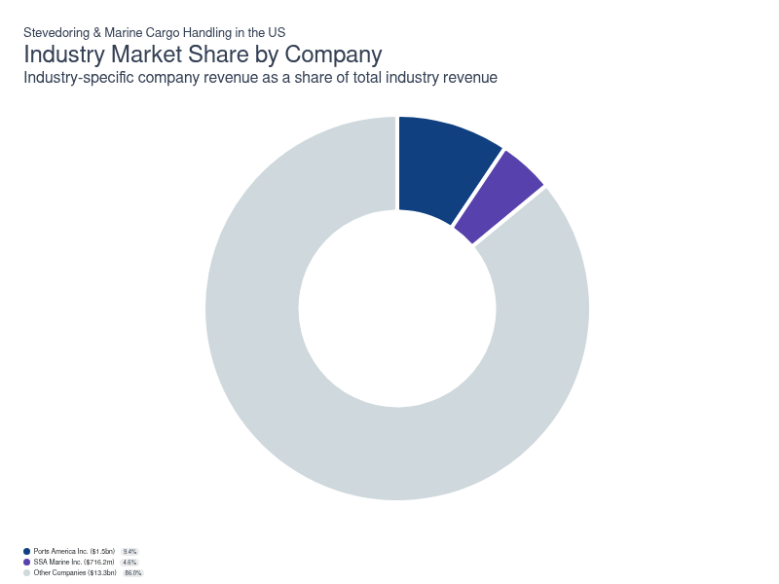
Chart displays current year only in the PDF version of this report. You can view and download chart for all other years associated with this industry on my.ibisworld.com.

Companies
Company | Market Share (%)  2025 | Revenue ($m)  2025 | Profit ($m)  2025 | Profit Margin (%)  2025
Ports America Inc. | 9.4 | 1,453.0 | 194.4 | 13.4
SSA Marine Inc. | 4.6 | 716.2 | 64.7 | 9.0

Ports America Inc.
Ports America Inc.
Company Details
Company Details
Industry Specific Revenue (2025) | $1.5bn
Industry Profit (2025) | $194.4m
Company Employees (2025) | 1,189
Market Share (2025) | 9.4%

Description
Description
Ports America is a private company with an estimated 1,189 employees. In the US, the company has a notable market share in at least one industry: Stevedoring & Marine Cargo Handling, where they account for an estimated 9.5% of total industry revenue and are considered a Golden Goose because they display medium to strong market share and strong profit, but slower revenue growth than some of their peers.

Company’s Industry Revenue, Market Share, and Profit Margin Over Time
Company’s Industry Revenue, Market Share, and Profit Margin Over Time
Year | Industry Revenue ($ million) | Market Share (%) | Profit Margin (%)
2020 | 1321 | 12.8 | 6.2
2021 | 1444 | 11.7 | 8.4
2022 | 1441 | 10.1 | 9.1
2023 | 1355 | 9.2 | 10.8
2024 | 1468 | 9.7 | 11.9
2025 | 1453 | 9.4 | 13.4

What's impacting Ports America Inc.'s performance?

CPP investments becomes the owner of Ports America
- Revealed in 2021, Canada Pension Plan Investment Board (CPP Investments) announced that it has become the owner of Ports America. Previously being a minority owner of the company since 2014, CPP Investments will support capital for current business activities at Ports America and will emphasize safety and efficiency for its entire shipping line. Moving forward, CPP Investments will seek to expand Ports America’s offerings while also growing its capabilities. After passing closing conditions and regulatory requirements, the deal closed during the fourth quarter of 2021.

Ports America achieves the Green Marine Certification
- Six Ports America terminals achieved Green Marine certification, the leading environmental certification program for North America's maritime industry.? This will make the company more appealing to ESG-related investors.

Investments in ports boost refrigerated goods and nearshoring commerce segments
- In May 2025, Ports America executives announced significant opportunities for refrigerated goods and nearshoring commerce, highlighting investments at Mississippi's Port of Gulfport, Port of New Orleans (including the Louisiana International Terminal) and Texas facilities, including Galveston's $70 million West End cargo complex.? Crowley launched a new weekly container service in late May 2025, connecting Gulfport with Tuxpan, Mexico, which Ports America supports as part of nearshoring initiatives.?

Labor strikes disrupt operations and emphasize the growing role of automation
- Ports America was significantly affected by the International Longshoremen's Association's first major strike since 1977, which began on October 1, 2024 and involved 50,000 dockworkers at 36 East and Gulf Coast ports. The three-day strike ended on October 4, 2024, when USMX (which represents Ports America and other terminal operators) agreed to a $4.00-per-hour wage increase and a tentative six-year contract with 62.0% total wage increases. The master contract was extended to January 15, 2025, to negotiate remaining issues, including automation and job preservation. Ports America and other USMX members reached a final tentative deal with the ILA on January 8, 2025.
SSA Marine Inc.
SSA Marine Inc.
Company Details
Company Details
Industry Specific Revenue (2025) | $716.2m
Industry Profit (2025) | $64.7m
Company Employees (2025) | 10,000
Market Share (2025) | 4.6%

Description
Description
SSA Marine is a private company with an estimated 10,000 employees. In the US, the company has a notable market share in at least one industry: Stevedoring & Marine Cargo Handling, where they account for an estimated 4.7% of total industry revenue and are considered a Laggard because they display lower market share alongside slower profit and revenue growth than their peers.

Company’s Industry Revenue, Market Share, and Profit Margin Over Time
Company’s Industry Revenue, Market Share, and Profit Margin Over Time
Year | Industry Revenue ($ million) | Market Share (%) | Profit Margin (%)
2020 | 583 | 5.6 | 4.7
2021 | 665 | 5.4 | 5.2
2022 | 721 | 5.0 | 6.4
2023 | 714 | 4.9 | 7.1
2024 | 722 | 4.7 | 8.2
2025 | 716 | 4.6 | 9.0

What's impacting SSA Marine Inc.'s performance?

SSA releases 2021 sustainability report
- In the SSA Marine Inc (SSA) 2021 sustainability report, the company outlines its sustainability procedures. One example is the Battery Electric Top Handler Demonstration. This program deployed four zero-emission battery-electric top handlers. The company reported that this demonstration has the following outcomes: Diesel Reduction of 18,000 gal/year and emission reduction (183 MTCO2/Yr). Furthermore, SSA states that this is among the earliest deployments of eTop handlers.

SSA Marine acquires Ceres Terminals
- SSA Marine's parent company Carrix completed the acquisition of Ceres Terminals from Macquarie Asset Management in September 2023. The deal was valued at approximately $1.0 billion and integrated Ceres' 18 locations across the US and Canada into SSA Marine operations. In January 2024, Carrix formally rebranded all Ceres Terminals operations under the SSA Marine brand, significantly expanding SSA Marine's footprint in the Gulf and Atlantic regions.?

SSA welcomes first vessel call to the newly modernized terminal in Seattle
- On January 7, 2022, SSA Marine (SSA) and the Northwest Seaport Alliance (NWSA) welcomed the first vessel to call into the newly modernized Terminal 5 in Seattle. Phase one of Terminal 5 is now open for cargo ships to call the NWSA gateway. The MSC Monterey is the first vessel to use the newly modernized terminal. The Terminal 5 Modernization program launched in 2016 to expand gateway cargo capacity and enable the NWSA to service the largest vessels in the Transpacific trade.

Labor strikes disrupt operations
- Dockers at the SSA Atlantic Terminal on Blount Island conducted a brief strike on March 11, 2025, because of a pay dispute. Workers walked out around 1 pm, leaving trucks waiting and machines attached to trucks. The International Longshoremen's Association resolved the conflict, so workers returned at 7 pm the same day.? SSA Marine's operations were also affected by the ILA's first major strike in nearly 50 years, which began on October 1, 2024, affecting 36 US East and Gulf Coast ports. The strike involved disputes over wages and automation between the ILA and the United States Maritime Alliance (USMX), which represents SSA Marine and other terminal operators.?

You can view and download company details on my.ibisworld.com.

8. External Environment
https://my.ibisworld.com/us/en/industry/48832/external-environment

Key Takeaways
- Stevedores and businesses handling marine cargo must develop and implement response and security plans to address potential spills and threats. The plans ensure compliance with environmental, security and labor regulations to protect ports, cargo and workers.
- Stevedores must adhere to international security measures set by the ISPS to ensure minimum safety standards. The measures include operational surveillance, restricted access areas and regular security audits to enhance port and ship security.
- Compliance with labor regulations ensures that stevedoring workers receive fair wages and work in safe conditions. The laws regulate working hours, overtime policies and occupational health and safety standards.
- Tariffs are a pivotal demand and routing driver. USTR actions under Section 301 increased and modified tariffs in 2024 and 2025, influencing sourcing, front-loading and port mix.​

External Drivers

What demographic and macroeconomic factors impact the industry?
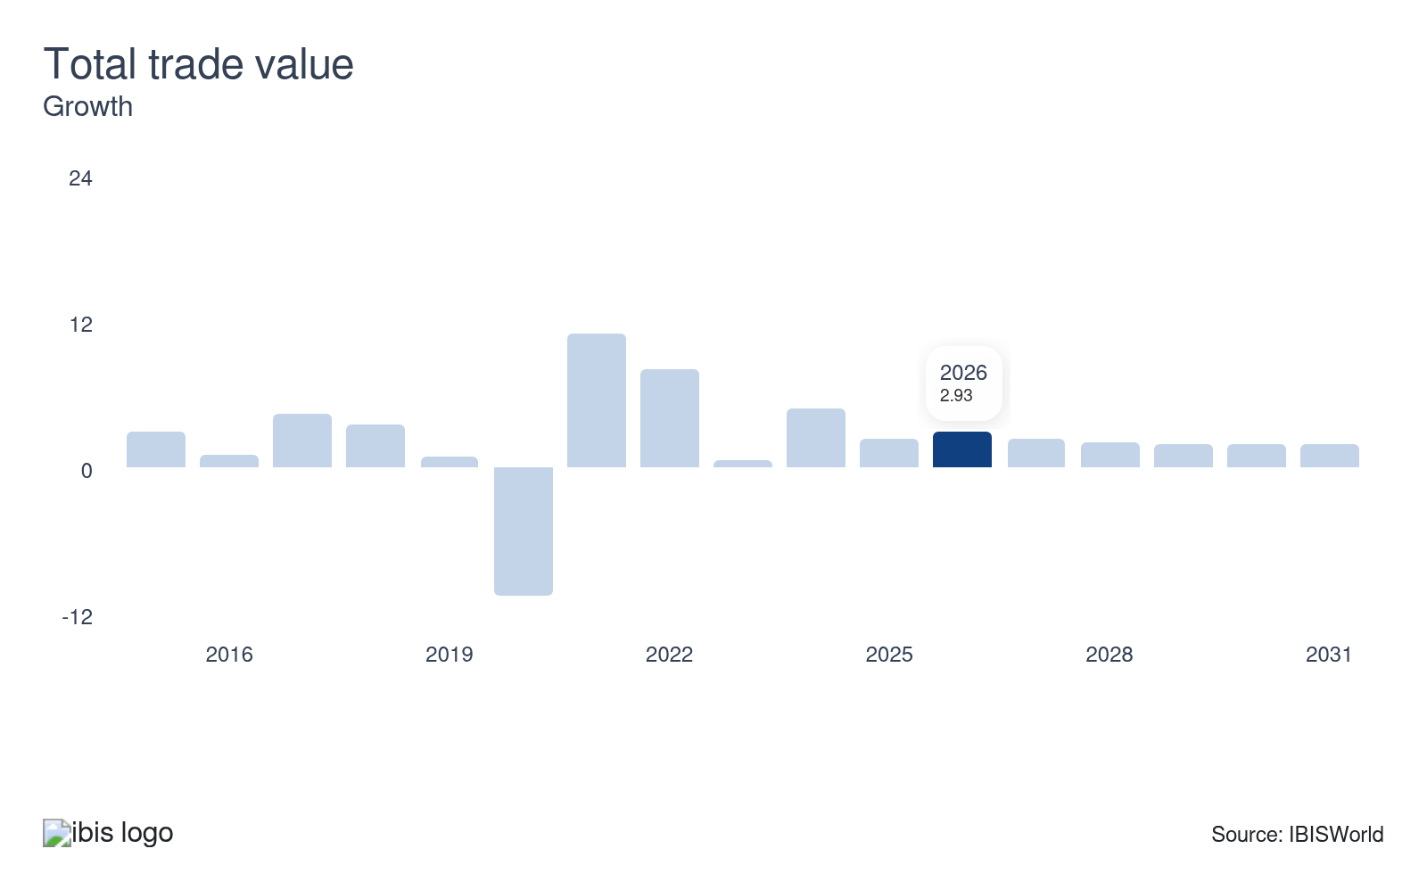
The usage of cargo loading and unloading equipment is driven by total trade value. As trade rises, ports and harbors become more reliant on efficient logistics to avoid bottlenecks and congestion. Stevedoring services ensure a steady cargo flow through the ports, often working under tight deadlines to compensate for any docking or ship arrival delays.
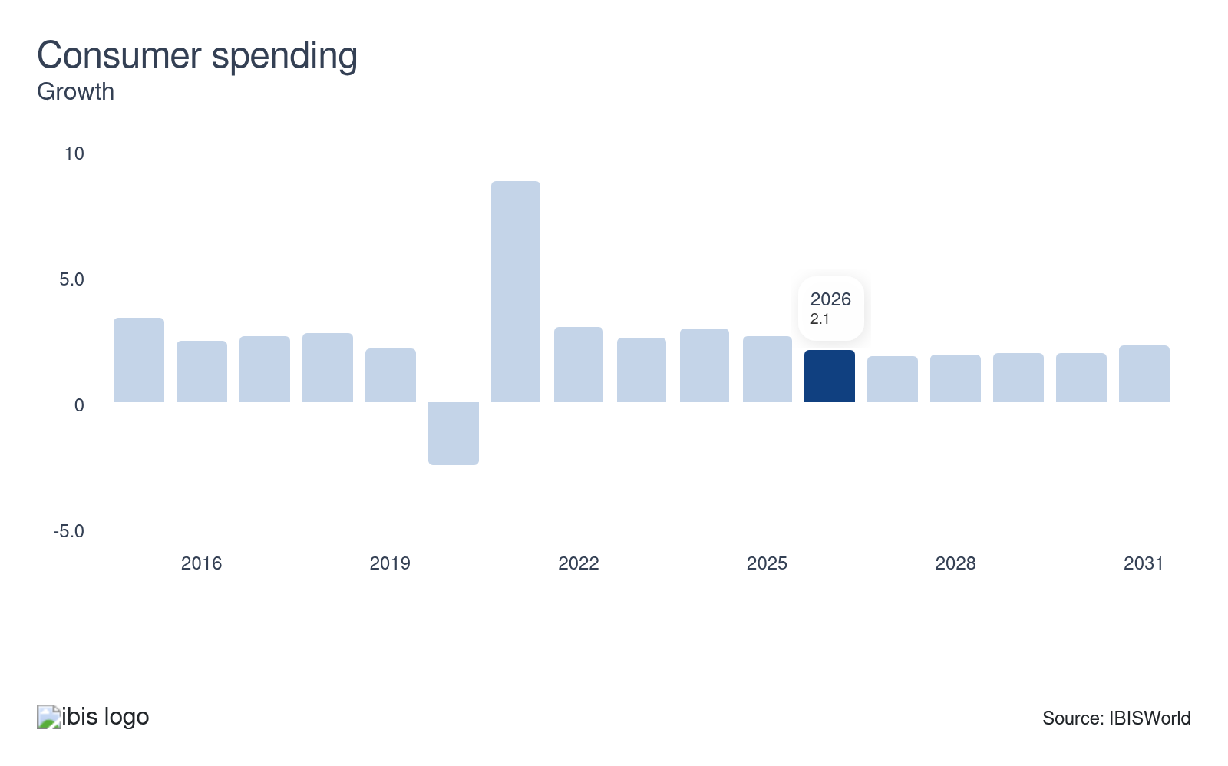
Consumer spending directly impacts total trade and the volume of transported goods. As consumer spending rises, import and export activities expand, leading to more shipping parcels and a higher demand for stevedoring and marine cargo handling.
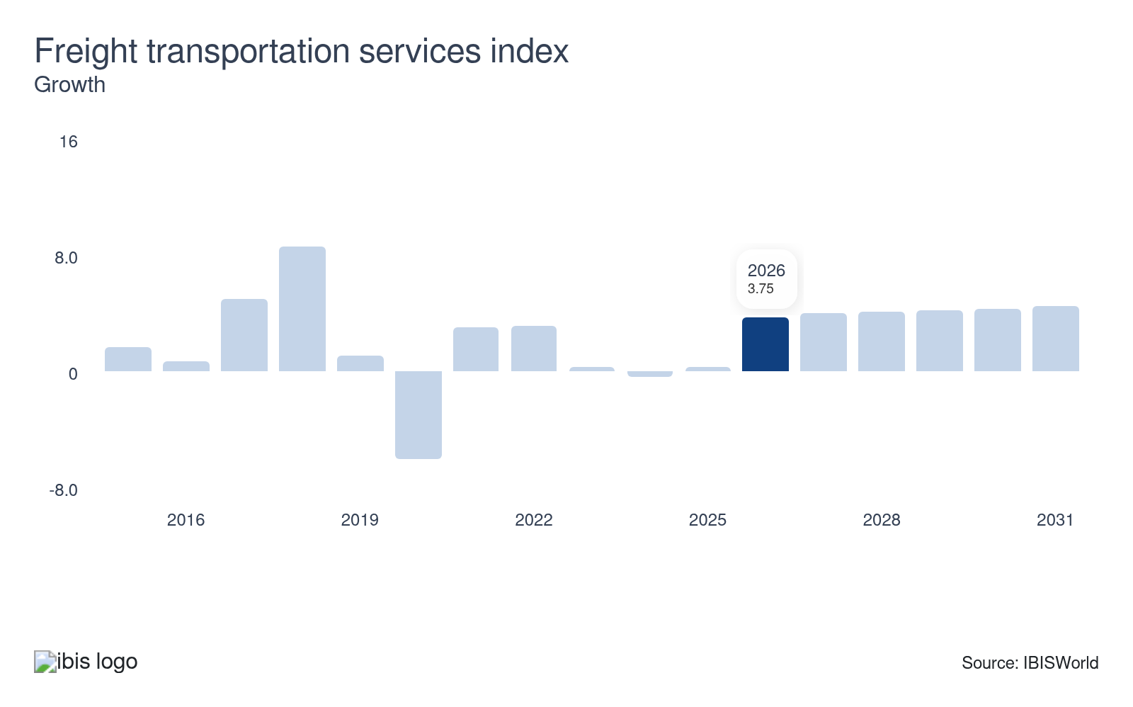
The annual output of freight transported domestically boosts the usage of inland ports. While water transportation makes up a smaller share of inland cargo, ports on riverbanks play a vital role in supporting economic activity. Rising domestic manufacturing propels the usage of waterways to distribute large quantities of cargo.
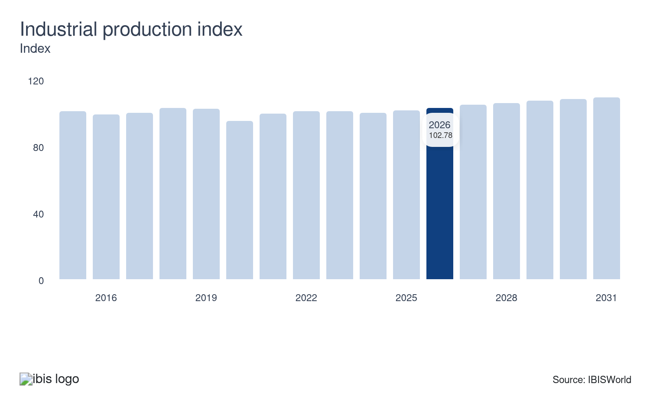
The industrial production index measures US mining, manufacturing, electric and gas output. The manufacturing sector relies heavily on waterborne transportation to receive input components and distribute manufactured goods to domestic and foreign markets. Industrial facilities are connected to many waterways, railroads and highways to ensure prompt delivery to market, boosting their reliance on stevedores' efficient cargo loading and unloading services.
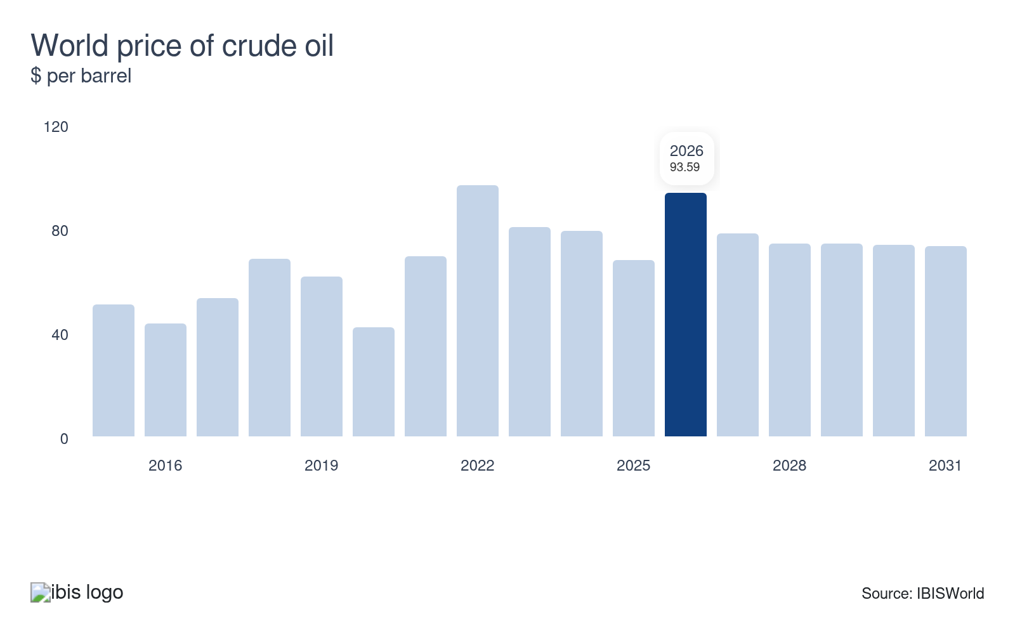
A climb in the world price of crude oil will boost the cost of transportation. In turn, companies in the industry will raise their fees to accommodate the greater cost of operations, resulting in rising revenue. Still, skyrocketing fuel prices can dampen economic activity, making goods unaffordable and hampering consumer sentiment, posing a potential threat to the industry.

Regulation & Policy
Moderate | Steady

What regulations impact the industry?

Marine Environmental Response Policy (CG-MER)
The CG-MER establishes guidelines and requirements to prevent, respond to and mitigate marine pollution incidents. The policies are enforced by the US Coast Guard and other federal agencies and require stevedores and other businesses handling marine cargo to develop and implement response plans to address potential spills and environmental hazards.

Maritime Transportation Security Act (MTSA)
The MTSA mandates enhanced security measures across ports and maritime facilities. It requires stevedores and port operators to develop and implement security plans that address potential threats and vulnerabilities, ensuring the safe handling of cargo and the protection of port infrastructure. Potential security plans can include screening cargo lists, requiring employee ID cards and managing radiation detectors at major ports to prevent security threats.

International Ship and Port Facility Security (ISPS)
ISPS sets the international benchmark for port and ship security. Stevedoring and cargo handling firms must adhere to these guidelines to ensure that minimum security measures are in place. These measures include operational surveillance systems, restricted access areas and regular security audits to deter crime and enhance security in ports and onboard ships.

Labor Law
Labor regulations under US law include statutes on occupational health and safety, wages and working hours. For stevedoring and marine cargo handling, this encompasses compliance with federal and state labor laws, ensuring that workers receive fair wages, work in safe conditions and adhere to regulated working hours and overtime policies.

OSHA Maritime Safety Standards (29 CFR Parts 1917 & 1918)
The Occupational Safety and Health Administration enforces comprehensive safety regulations designed for marine cargo handling operations through two primary standards. Part 1917 governs marine terminal operations, covering employment within marine terminals, including loading, unloading and handling cargo between vessels and land carriers. Part 1918 addresses longshoring operations aboard vessels. These regulations establish mandatory requirements for housekeeping, cargo handling procedures, personal protective equipment, walking and working surfaces and access control measures. Marine terminals must comply with requirements for certification of shore-based material handling devices such as cranes and derricks under 29 CFR Part 1919, which mandates thorough examinations and proof load testing before initial use, annually and every four years. Violations of these standards can result in significant civil and criminal penalties.

Jones Act Cabotage Requirements (46 USC § 55102)
The Jones Act establishes strict domestic shipping restrictions requiring that all cargo transported by water between United States points must be carried on vessels that are US-built, US-owned, with at least 75.0% US citizen ownership, US-flagged and registered in a US port and crewed by at least 75.0% US citizens or permanent residents. These cabotage provisions directly impact stevedoring operations by determining which vessels can call at US ports for domestic cargo movements, affecting cargo volumes, scheduling and operational planning for marine terminals.

Coast Guard Dangerous Cargo Regulations (33 CFR Parts 126 & 127)
Coast Guard regulations under 33 CFR Part 126 govern dangerous cargo handling at waterfront facilities, including bulk solid and packaged hazardous materials. Facilities handling these materials must obtain Coast Guard permits, develop and maintain operations manuals, designate qualified persons in charge of dangerous cargo operations, implement security measures to prevent unauthorized access, maintain proper separation distances and conduct regular inspections and emergency drills. Part 127 addresses waterfront facilities handling liquefied natural gas and hazardous gases, imposing additional stringent requirements for facilities handling these dangerous cargoes. The regulations require coordination with vessel operators during cargo transfer operations, proper grounding and bonding procedures, vapor recovery system operations where applicable and immediate reporting of incidents or irregularities.

Assistance
Low | Steady

What assistance is available to this industry?

Tariff reductions and subsidies
Reductions in general tariff rates boost imports from foreign manufacturers, increasing the volume of marine cargo entering the US and driving demand for cargo handling services. Conversely, higher tariffs pressure trade activity and moderate revenue growth. US government subsidies for domestically grown agricultural products indirectly benefit cargo handling as subsidies enhance the global competitiveness of the US agricultural sector, leading to greater shipping volumes and an increased need for stevedoring and marine cargo handling.

Infrastructure Investment and Jobs Act
The $1.2 trillion Infrastructure Investment and Jobs Act (IIJA) benefits stevedores through significant capital investments. Programs like the Port Infrastructure Development Program Grants and projects by the Federal Emergency Management Agency help improve port facilities and handling equipment. Investments in modernizing port facilities enhance operational efficiency and elevate companies' handling capacity, leading to a lower vessel turnaround time and higher revenues. Funds provided under the IIJA will be discontinued in 2026.

EPA Clean Ports Program
The EPA's $3.0 billion Clean Ports Program funds US ports' zero-emission cargo handling equipment and infrastructure. The program has awarded grants supporting over 1,500 units of cargo handling machinery, including electric forklifts, terminal tractors, reach stackers and automated stacking cranes. Funding covers 30-60.0% of equipment costs, depending on technology type. The program prioritizes ports in disadvantaged communities and supports workforce training for operating and maintaining new zero-emission technologies. This initiative directly benefits stevedoring companies, modernizing their cargo handling operations.​

MARAD Federal Ship Program
MARAD's $1.3 billion Federal Ship Financing Program (Title XI) provides loan guarantees for vessel construction and modernization, supporting the commercial maritime infrastructure that stevedoring operations depend upon. The Maritime Environmental and Technical Assistance (META) program receives $6.0 million annually to support innovation in marine transportation, with 75.0% focused on decarbonization technologies affecting cargo handling equipment. These programs help stevedoring companies access capital for equipment upgrades and adopt emerging technologies that improve operational efficiency and environmental performance.

Maritime Law Association (MLA)
The MLA shapes and assists in interpreting maritime laws and regulations. The organization works to ensure that the legal standards are transparent, fair and conducive to the smooth operations of marine commerce. The association collaborates with government entities and advocates for laws that balance the needs of maritime businesses with safety and environmental considerations.

ILWU-PMA Training and Workforce Development Programs
The International Longshore and Warehouse Union (ILWU) partners with the Pacific Maritime Association (PMA) to operate advanced training facilities, including the $16.4 million Maintenance and Repair Training Center at the Port of Los Angeles. Programs provide upskill and reskill training for many registered longshore workers annually, covering automated equipment maintenance, zero-emission technology repair, and advanced cargo handling techniques. Training includes mechanical systems, electrical diagnostics, and equipment operation certification. These labor-management partnerships ensure workforce readiness for evolving stevedoring technologies and operations.​​

Industry Associations Professional Development Programs
The American Association of Port Authorities (AAPA) offers Certified Port Executive programs, technical training seminars and Professional Port Manager certification specifically addressing stevedoring and cargo handling management. AAPA provides specialized education covering cargo handling equipment, terminal operations, safety management and regulatory compliance. The association facilitates knowledge sharing through technical committees, best practice workshops and peer networking. Training programs address emerging issues, including port electrification, automation implementation and environmental sustainability. This helps stevedoring professionals advance skills and maintain industry competitiveness.​

9. Financial Benchmarks
https://my.ibisworld.com/us/en/industry/48832/financial-benchmarks
Profit Margin  10.8 %  ↑ Higher than sector | Average Wage  $94,288  ↑ Higher than sector | Largest Cost  Wages  41.2% of Revenue

Key Takeaways
- Commodity-price inflation drove substantial purchases for businesses reliant on steel and energy prices. Fluctuations caused by supply chain disruptions and geopolitical conflicts initially spiked costs, but the price moderation offers some relief.
- Automation and software integration are pressuring wages. Despite efficiency improvements, businesses still have to negotiate high salaries because of the substantial labor union presence and the industry's labor-intensive nature.
- PPI signals pricing power and cost pass-through. The Marine Cargo Handling PPI offers timely readouts on rate and surcharge dynamics relative to labor, equipment and energy inputs.​
- BTS port measures (TEUs, vessel time at berth and calls) complement financials to assess productivity, capacity usage and congestion risks.​ Higher port volumes typically indicate a greater need for stevedoring and marine cargo handling.

Cost Structure
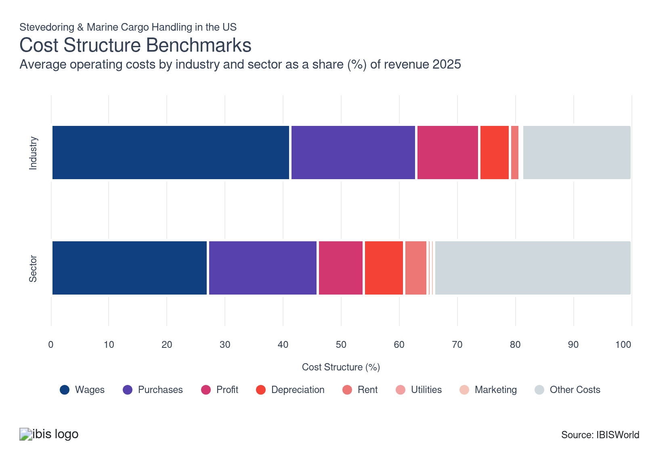
Chart displays current year only in the PDF version of this report. You can view and download chart for all other years associated with this industry on my.ibisworld.com.

What trends impact industry costs?

Technological advancements and supply chain disruptions drive profit growth
- Profit as a revenue share rose over the last five years because of automation-driven labor cost reduction, pricing power from market concentration and operational efficiency gains. Implementing technological solutions and software to monitor incoming and outgoing parcels improved companies' profit margin despite the initial costs associated with capital expenditures on new equipment and ongoing inflationary pressures.
- While input cost volatility, such as diesel and oil price shocks, posed challenges at the beginning of the period, strategic adjustments after 2022 limited the impact on stevedoring and marine cargo handling. Higher cargo volumes during 2020 through 2022 and strong LNG/agricultural export growth further boosted revenue without proportional cost increases, widening profit margin. ​Ports that became congested experienced supply chain difficulties, allowing businesses to raise prices on incoming shipments.
- Profits are expected to improve further in the long run as businesses gain expertise in deploying the newly adopted software and expand their use of AI and cloud-related solutions, driving efficiency. With tariffs imposed on cargo in 2025, fragmented stevedoring companies must compete on price to secure favorable contracts and protect their profit margin.

Automation and software integration pressure wages
- Incumbent enterprises mitigate labor costs by investing in scanning software and modern machinery to reduce dependency on labor. Streamlining operations and deploying technology to better analyze incoming parcels allows for more accurate distribution and quicker loading processes while also reducing the need for manual labor.
- Despite the automation, stevedoring remains highly labor-intensive. The strong influence of the International Longshore and Warehouse Union contributes to high wage costs as companies are forced to negotiate improved salary packages and often lack the flexibility to lay off staff during economic slowdowns.
- Technological advancements are expected to continue driving efficiency and pressuring wages in the short term. Still, a climb in total trade value following the likely loosening of monetary policy is expected to drive hiring.

Inflation in commodities drives purchase costs
- Businesses remain reliant on steel and energy prices. Stevedores purchase equipment, fuel, cranes and other equipment tailored to handling different types of cargo. Purchases remained stable as a revenue share over the last five years because fuel, equipment parts and materials costs tracked closely with cargo volumes and pricing mechanisms passed through commodity volatility. Marine diesel costs fluctuated with crude oil markets but included consistent markup structures from refining, distribution and bunkering fees that stevedores absorbed proportionally to throughput.
- Supply chain disruptions initially caused volatility in commodity prices, while the Russia-Ukraine war and the conflict in the Middle East exacerbated the fluctuations. The initial spike in steel prices played into higher purchase costs between 2021 and 2022. Since then, steel prices have moderated, offering some relief. Still, 2025 tariffs on steel pushed up prices from January 2025 levels.
- The 2020 IMO sulfur regulations increased low-sulfur fuel costs by $70.00 to $90.00 per ton, but stevedores adjusted pricing and passed costs to customers, leading to higher revenue. However, rising oil prices at the beginning of the period continued to push up purchase costs tied to fuel for trucks and cranes. Because stevedores are responsible for using this equipment in their operations, fuel costs in the contract raised purchase costs in 2021 and 2022.
- With moderating oil prices after 2022, adequate supplies met lower demand and offered some relief for purchase costs. If the announced October 2025 sanctions on Russia's two biggest oil-producing companies do not materialize, oil prices will likely remain below 2022 and 2023 levels, providing less upward pressure on purchases.

Renewed investments lead to higher depreciation after cautious spending patterns
- Depreciation fell from 2020 to 2022 as operators delayed capital investment during pandemic uncertainty, then rose from 2022 to 2025 as automation projects and infrastructure modernization accelerated. Full terminal automation projects substantial capital expenditures and lengthy periods for return on investment. This also leads operators to defer investments throughout 2020 and 2021.
- As supply chains stabilized in 2022, major capital deployments resumed. The Infrastructure Investment and Jobs Act allocated $2.25 billion for port infrastructure through 2026, triggering facility upgrades, crane acquisitions and automated guided vehicle installations. For instance, SSA Marine deployed 100.0% zero-emissions equipment at Los Angeles Berth 55 by May 2025, while Jacksonville's $72.0 million terminal expansion represented typical post-2022 capital intensity. If investments accelerate, depreciation will likely climb as a revenue share.

Other costs scale proportionally to terminal size and cargo volumes
- Other costs, including insurance and maintenance, remained stable as a revenue share over the last five years because risk profiles, regulatory compliance requirements and preventive maintenance protocols scaled proportionally with operations. Insurance premiums for terminals, equipment and liability coverage tracked closely with asset values and cargo throughput, maintaining consistent expense ratios despite occasional claims spikes from pandemic disruptions or extreme weather.
- Maintenance costs for cranes, automated guided vehicles and handling equipment followed predictable schedules tied to equipment age and utilization hours, with OEM service contracts locking in costs as percentage-of-equipment-value formulas. Regulatory compliance expenses for environmental standards, safety protocols and security measures increased nominally but remained proportional to terminal size and cargo volumes. Utilities and facility overhead costs scaled with throughput intensity, keeping other expenses stable relative to revenue growth.
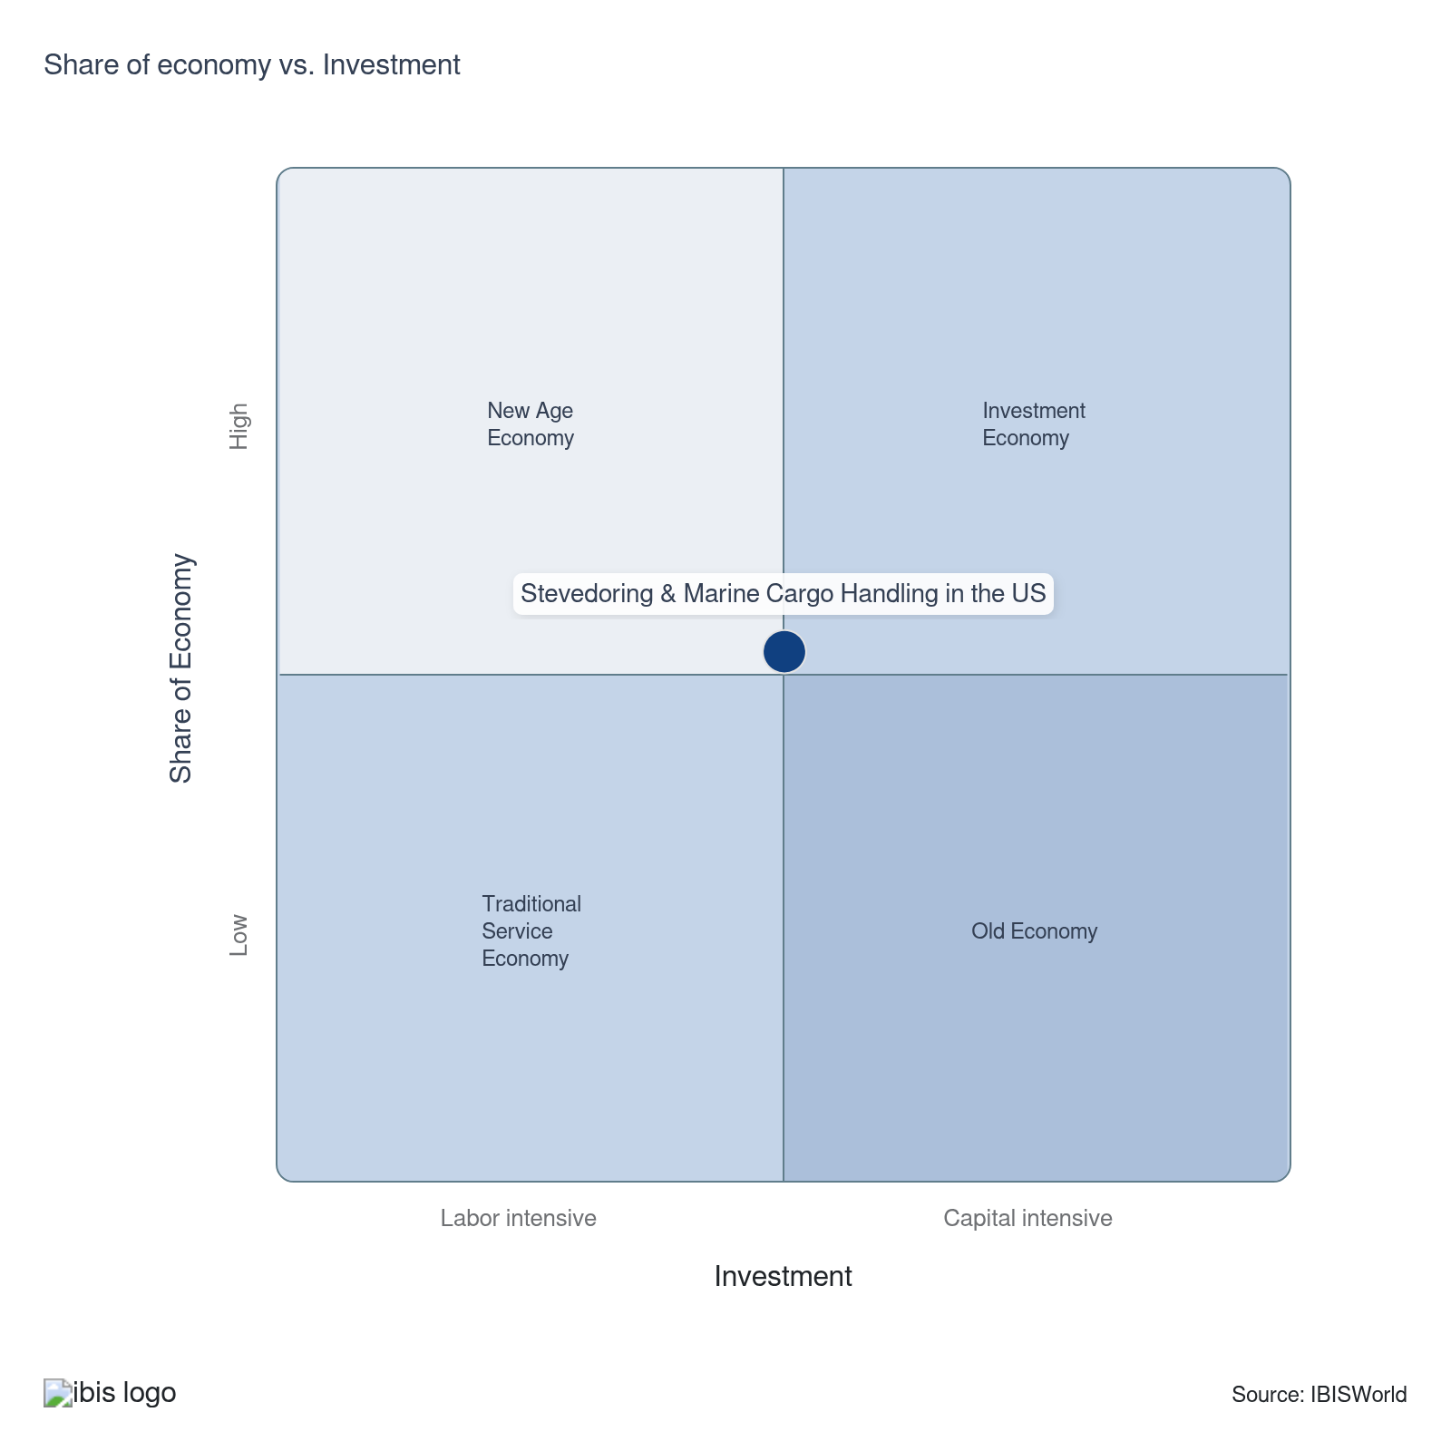

Financial Ratios

Earnings Ratios
Ratio | 2020 | 2021 | 2022 | 2023 | 2024 | 3-Year | 5-Year | 10-Year
EBIT/Revenue | 20.7 | 26.5 | 6.2 | 12.8 | 11.5 | 12.1 | 14.3 | 12.8
EBITDA/Revenue | 27.5 | 32.4 | 12.7 | 16.1 | 15.7 | 15.9 | 19.2 | 18.8
Leverage Ratio | 3.6 | 3.1 | 7.9 | 6.2 | 6.4 | 6.3 | 5.9 | 5.9

Industry Tax Structure
Ratio | 2020 | 2021 | 2022 | 2023 | 2024 | 3-Year | 5-Year | 10-Year
Taxes Paid/Revenue | 0.6 | 1.2 | 1.9 | 2.0 | 1.8 | 1.9 | 1.7 | 1.9

Income Statement
Ratio | 2020 | 2021 | 2022 | 2023 | 2024 | 3-Year | 5-Year | 10-Year
Total Revenue | 100.0 | 100.0 | 100.0 | 100.0 | 100.0 | 100.0 | 100.0 | 100.0
Business receipts | 88.7 | 90.1 | 92.4 | 90.9 | 97.5 | 94.2 | 92.7 | 90.9
Cost of goods | 37.5 | 36.4 | 48.2 | 30.2 | 28.6 | 29.4 | 35.9 | 40.4
Gross Profit | 62.5 | 63.6 | 51.8 | 69.8 | 71.4 | 70.6 | 64.1 | 59.6
Expenses
Salaries and wages | 4.1 | 3.4 | 4.5 | 8.0 | 7.8 | 7.9 | 5.9 | 5.9
Advertising | 1.9 | 1.8 | 0.4 | 1.3 | 1.2 | 1.2 | 1.2 | 1.1
Depreciation | 3.8 | 3.0 | 3.5 | 2.6 | 2.7 | 2.6 | 2.9 | 3.4
Depletion | 2.1 | 1.6 | 1.7 | 0.6 | 1.3 | 0.9 | 1.3 | 1.8
Amortization | 0.9 | 1.3 | 1.3 | 0.1 | 0.3 | 0.2 | 0.7 | 0.8
Rent paid | 0.9 | 0.7 | 1.0 | 1.7 | 1.8 | 1.8 | 1.3 | 1.3
Repairs | 0.7 | 0.6 | 0.7 | 1.7 | 0.9 | 1.3 | 1.0 | 0.8
Bad debts | 0.1 | 0.2 | 0.0 | 2.5 | 1.2 | 1.8 | 1.0 | 0.5
Employee benefit programs | 1.9 | 1.4 | 1.7 | 3.9 | 3.8 | 3.8 | 2.7 | 2.4
Compensation of officers | 1.5 | 1.3 | 1.5 | 6.6 | 9.0 | 7.8 | 4.6 | 3.0
Taxes paid | 0.6 | 1.2 | 1.9 | 2.0 | 1.8 | 1.9 | 1.7 | 1.9
Interest Income | 0.6 | 0.5 | 0.6 | 0.3 | 0.0 | 0.2 | 0.4 | 0.5
Other Income
Royalties | 1.9 | 1.5 | 0.9 | 0.5 | 1.2 | 0.8 | 1.0 | 1.3
Rent Income | 4.7 | 3.6 | 3.0 | 1.4 | 0.1 | 0.8 | 2.0 | 3.4
Net Income | 17.9 | 23.7 | 2.3 | 8.4 | 8.1 | 8.2 | 10.6 | 8.9
Charitable contributions | 0.2 | 0.2 | 0.1 | 0.2 | 0.1 | 0.1 | 0.1 | 0.1
Dividends | 0.5 | 1.0 | 0.1 | 1.2 | 0.3 | 0.8 | 0.6 | 0.4
Interest paid | 2.2 | 1.7 | 2.0 | 2.4 | 1.6 | 2.0 | 1.9 | 2.0
Net gain, noncapital assets | 1.5 | 1.2 | 1.0 | 1.4 | 0.1 | 0.8 | 0.9 | 1.2
Net long-term capital gain less net short-term loss | 0.4 | 0.4 | 0.4 | 0.2 | 0.0 | 0.1 | 0.2 | 0.3
Net loss, noncapital assets | 2.3 | 1.7 | 1.9 | 0.6 | 0.3 | 0.5 | 1.1 | 1.8
Net short-term capital gain less net long-term loss | 0.2 | 0.0 | 0.2 | 2.5 | 0.2 | 1.4 | 0.7 | 0.4
Other deductions | 20.5 | 19.1 | 26.4 | 25.3 | 27.4 | 26.3 | 24.5 | 22.5
Other receipts | 1.6 | 1.6 | 1.6 | 1.6 | 0.3 | 1.0 | 1.3 | 1.5
Pension, profit-sharing, etc., plans | 1.0 | 0.8 | 0.9 | 2.0 | 2.2 | 2.1 | 1.5 | 1.3

Balance Sheet
Ratio | 2020 | 2021 | 2022 | 2023 | 2024 | 3-Year | 5-Year | 10-Year
Assets
Cash and Equivalents | 12.4 | 7.8 | 5.0 | 6.8 | 5.4 | 6.1 | 6.2 | 6.6
Notes and accounts receivable | 18.5 | 21.6 | 18.9 | 10.2 | 8.1 | 9.1 | 14.7 | 14.5
Allowance for bad debts | 0.3 | 0.5 | 0.6 | 0.5 | 0.7 | 0.6 | 0.6 | 0.5
Inventories | 4.0 | 3.6 | 2.5 | 5.3 | 9.9 | 7.6 | 5.3 | 3.8
Other current assets | 4.1 | 1.8 | 2.6 | 5.5 | 4.7 | 5.1 | 3.7 | 3.4
Other investments | 13.3 | 12.2 | 13.5 | 11.0 | 11.4 | 11.2 | 12.0 | 11.8
Property, Plant and Equipment | 53.1 | 47.4 | 47.9 | 36.6 | 34.6 | 35.6 | 41.6 | 49.0
Accumulated depreciation | 31.1 | 25.1 | 19.3 | 22.3 | 20.6 | 21.4 | 21.8 | 23.3
Intangible assets (Amortizable) | 9.2 | 6.7 | 8.1 | 21.1 | 22.1 | 21.6 | 14.5 | 13.1
Accumulated amortization | 1.6 | 1.5 | 1.6 | 3.3 | 3.5 | 3.4 | 2.5 | 1.7
Other assets | 13.8 | 12.8 | 10.6 | 8.8 | 8.9 | 8.9 | 10.3 | 9.7
Total assets | 100.0 | 100.0 | 100.0 | 100.0 | 100.0 | 100.0 | 100.0 | 100.0
Accounts payable | 4.2 | 3.9 | 5.0 | 4.7 | 4.1 | 4.4 | 4.4 | 5.0
Liabilities and Net Worth
Mort, notes, and bonds under 1 yr | 5.3 | 8.0 | 7.6 | 8.4 | 9.2 | 8.8 | 8.3 | 7.5
Other current liabilities | 5.8 | 6.8 | 7.5 | 8.3 | 6.5 | 7.4 | 7.3 | 6.4
Loans from shareholders | 0.9 | 0.1 | 1.0 | 2.0 | 3.4 | 2.7 | 1.6 | 1.9
Mort, notes, bonds, 1 yr or more | 45.7 | 42.8 | 41.7 | 42.2 | 42.7 | 42.5 | 42.4 | 41.0
Other liabilities | 18.9 | 19.3 | 18.1 | 11.2 | 10.7 | 11.0 | 14.8 | 16.5
Total liabilities | 100.0 | 100.0 | 100.0 | 100.0 | 100.0 | 100.0 | 100.0 | 100.0
Capital stock | 2.0 | -5.8 | 0.5 | 2.6 | 0.9 | 1.7 | -0.4 | 1.0
Additional paid-in capital | 18.4 | 17.3 | 21.7 | 20.4 | 22.3 | 21.3 | 20.4 | 21.7
Retained earnings, appropriated | -3.4 | -6.4 | -0.5 | -4.1 | -3.6 | -3.8 | -3.7 | -2.0
Retained earnings-unappropriated | 26.6 | 38.2 | 28.6 | 26.1 | 23.9 | 25.0 | 29.2 | 22.9
Cost of treasury stock | 24.4 | 24.3 | 31.3 | 21.7 | 20.1 | 20.9 | 24.3 | 21.8
Net worth | 19.3 | 19.0 | 19.1 | 23.3 | 23.3 | 23.3 | 21.2 | 21.8
Accumulated depletion | 0.0 | 0.0 | 0.0 | 0.5 | 0.2 | 0.3 | 0.2 | 0.1
Depletable assets | 0.0 | 7.1 | 5.1 | 1.9 | 1.1 | 1.5 | 3.8 | 3.7
Government Obligations | 0.2 | 0.2 | 0.2 | 0.3 | 0.3 | 0.3 | 0.2 | 0.2
Land | 3.9 | 4.2 | 4.4 | 4.6 | 4.7 | 4.7 | 4.5 | 4.3
Loans to shareholders | 0.6 | 0.6 | 0.5 | 1.3 | 1.3 | 1.3 | 0.9 | 0.8
Mortgage and real estate loans | 0.0 | 1.2 | 2.2 | 12.8 | 12.1 | 12.5 | 7.1 | 4.4
Tax Exempt Securities | 0.0 | 0.0 | 0.0 | 0.2 | 0.4 | 0.3 | 0.2 | 0.1

Liquidity Ratios
Ratio | 2020 | 2021 | 2022 | 2023 | 2024 | 3-Year | 5-Year | 10-Year
Current Ratio | 2.6 | 1.9 | 1.5 | 1.4 | 1.5 | 1.4 | 1.6 | 1.6
Quick Ratio | 2.3 | 1.7 | 1.4 | 1.1 | 1.0 | 1.0 | 1.3 | 1.4
Sales/Receivables | 5.4 | 4.6 | 5.3 | 9.8 | 12.4 | 11.1 | 8.0 | 7.5
Days' Receivables | 67.5 | 79.0 | 69.1 | 37.2 | 29.4 | 33.3 | 53.7 | 53.1
Days' Inventory | 39.1 | 36.3 | 19.2 | 64.0 | 126.1 | 95.0 | 61.4 | 39.5
Inventory Turnover | 9.3 | 10.1 | 19.0 | 5.7 | 2.9 | 4.3 | 9.4 | 14.6
Payables Turnover | 9.0 | 9.3 | 9.6 | 6.5 | 6.9 | 6.7 | 8.1 | 9.4
Days' Payables | 40.6 | 39.5 | 38.1 | 56.3 | 52.8 | 54.6 | 46.7 | 45.7
Sales/Working Capital | 3.7 | 5.4 | 9.6 | 12.1 | 10.3 | 11.2 | 9.3 | 10.7

Coverage Ratios
Ratio | 2020 | 2021 | 2022 | 2023 | 2024 | 3-Year | 5-Year | 10-Year
Interest Coverage | 9.5 | 16.0 | 3.1 | 5.3 | 7.3 | 6.3 | 7.9 | 6.8
Debt Service Coverage Ratio | 9.3 | 12.7 | 4.9 | 4.9 | 4.7 | 4.8 | 6.8 | 7.5

Leverage Ratios
Ratio | 2020 | 2021 | 2022 | 2023 | 2024 | 3-Year | 5-Year | 10-Year
Fixed Assets/Net Worth | 5.1 | 4.8 | 4.5 | 3.9 | 3.7 | 3.8 | 4.2 | 4.5
Debt/Net Worth | 5.2 | 5.3 | 5.2 | 4.3 | 4.3 | 4.3 | 4.8 | 4.7
Tangible Net Worth | 19.3 | 19.0 | 19.1 | 23.3 | 23.3 | 23.3 | 21.2 | 21.8

Operating Ratios
Ratio | 2020 | 2021 | 2022 | 2023 | 2024 | 3-Year | 5-Year | 10-Year
Return on Net Worth, % | 107.4 | 139.5 | 32.7 | 54.9 | 49.3 | 52.1 | 69.1 | 60.6
Return on Assets, % | 20.7 | 26.5 | 6.2 | 12.8 | 11.5 | 12.1 | 14.3 | 12.8
Sales/Total Assets | 1.0 | 1.0 | 1.0 | 1.0 | 1.0 | 1.0 | 1.0 | 1.0
EBITDA/Revenue | 27.5 | 32.4 | 12.7 | 16.1 | 15.7 | 15.9 | 19.2 | 18.8
EBIT/Revenue | 20.7 | 26.5 | 6.2 | 12.8 | 11.5 | 12.1 | 14.3 | 12.8

Cash Flow & Debt Service Ratios (% of sales)
Ratio | 2020 | 2021 | 2022 | 2023 | 2024 | 3-Year | 5-Year | 10-Year
Cash from Trading | 64.7 | 67.4 | 49.0 | 58.7 | 65.2 | 61.9 | 60.1 | 58.0
Cash after Operations | 53.9 | 63.0 | 40.8 | 37.3 | 43.5 | 40.4 | 46.1 | 45.7
Net Cash after Operations | 55.0 | 61.9 | 39.6 | 36.6 | 45.0 | 40.8 | 45.8 | 45.3
Debt Service P&I Coverage | 6.5 | 6.0 | 3.7 | 2.9 | 3.6 | 3.2 | 4.0 | 4.3
Interest Coverage (Operating Cash) | 25.2 | 37.4 | 19.7 | 15.2 | 28.4 | 21.8 | 25.2 | 23.9

Valuation Multiples

Valuation Multiples
Ratio | 2020 | 2021 | 2022 | 2023 | 2024 | 3-Year | 5-Year | 10-Year
EV/Revenue | 0.6 | 0.6 | 0.6 | 0.7 | 0.7 | 0.7 | 0.7 | 0.7
EV/EBITDA | 2.3 | 1.3 | 2.5 | 2.2 | 2.2 | 2.3 | 2.1 | 2.0
EV/EBIT | 6.2 | 1.8 | 5.2 | 2.7 | 3.2 | 3.7 | 3.8 | 3.6

Key Ratios
Year | Revenue per Employee  ($) | Revenue per Enterprise  ($ Million) | Employees per Estab.  (Units) | Employees per Enterprise  (Units) | Average Wage  ($) | Wages/ Revenue  (%) | Estab. per Enterprise  (Units) | IVA/ Revenue  (%)
2002 | 145,835 | 19.4 | 84.8 | 132.7 | 81,651 | 56.0 | 1.6 | 70.2
2003 | 147,211 | 20.8 | 93.4 | 141.1 | 79,644 | 54.1 | 1.5 | 70.6
2004 | 147,570 | 25.1 | 106.4 | 169.9 | 80,214 | 54.4 | 1.6 | 71.9
2005 | 147,262 | 25.2 | 108.7 | 171.0 | 79,953 | 54.3 | 1.6 | 71.7
2006 | 147,047 | 25.9 | 114.6 | 176.4 | 80,362 | 54.7 | 1.5 | 73.3
2007 | 147,358 | 27.2 | 114.0 | 184.6 | 80,869 | 54.9 | 1.6 | 69.7
2008 | 166,839 | 38.1 | 119.8 | 228.4 | 74,796 | 44.8 | 1.9 | 60.9
2009 | 187,491 | 36.2 | 104.2 | 193.1 | 71,299 | 38.0 | 1.9 | 55.8
2010 | 189,106 | 35.2 | 113.0 | 186.0 | 75,595 | 40.0 | 1.6 | 59.4
2011 | 193,522 | 36.1 | 109.2 | 186.6 | 74,414 | 38.5 | 1.7 | 56.5
2012 | 279,549 | 53.5 | 127.8 | 191.4 | 81,664 | 29.2 | 1.5 | 47.4
2013 | 181,944 | 45.9 | 144.8 | 252.1 | 83,375 | 45.8 | 1.7 | 63.1
2014 | 186,128 | 46.1 | 144.9 | 247.6 | 83,914 | 45.1 | 1.7 | 65.7
2015 | 205,673 | 46.6 | 135.0 | 226.7 | 85,987 | 41.8 | 1.7 | 59.1
2016 | 204,552 | 43.6 | 127.4 | 213.2 | 91,448 | 44.7 | 1.7 | 66.0
2017 | 215,048 | 45.9 | 122.2 | 213.3 | 98,653 | 45.9 | 1.7 | 65.4
2018 | 213,387 | 49.9 | 135.2 | 234.1 | 95,911 | 44.9 | 1.7 | 63.3
2019 | 192,775 | 47.1 | 143.8 | 244.5 | 90,068 | 46.7 | 1.7 | 70.9
2020 | 187,658 | 46.4 | 143.5 | 247.2 | 87,817 | 46.8 | 1.7 | 61.2
2021 | 232,131 | 51.4 | 128.4 | 221.4 | 102,375 | 44.1 | 1.7 | 56.1
2022 | 224,835 | 55.5 | 145.6 | 247.0 | 94,992 | 42.2 | 1.7 | 55.1
2023 | 229,961 | 54.0 | 137.9 | 234.7 | 94,394 | 41.0 | 1.7 | 56.5
2024 | 230,342 | 54.4 | 138.8 | 236.3 | 94,427 | 41.0 | 1.7 | 56.5
2025 | 228,643 | 54.0 | 138.9 | 236.1 | 94,288 | 41.2 | 1.7 | 57.4
2026 | 227,511 | 53.7 | 138.6 | 236.0 | 94,195 | 41.4 | 1.7 | 57.9
2027 | 228,715 | 54.2 | 139.1 | 236.8 | 94,296 | 41.2 | 1.7 | 57.8
2028 | 229,597 | 54.4 | 139.4 | 236.9 | 94,369 | 41.1 | 1.7 | 57.3
2029 | 229,951 | 55.0 | 140.2 | 239.1 | 94,398 | 41.1 | 1.7 | 57.4
2030 | 230,936 | 55.2 | 140.5 | 239.2 | 94,477 | 40.9 | 1.7 | 57.6
2031 | 231,662 | 55.7 | 141.0 | 240.5 | 94,538 | 40.8 | 1.7 | 57.5
*Figures are inflation adjusted to 2025
*Figures are inflation adjusted to 2025

10. Key Statistics
https://my.ibisworld.com/us/en/industry/48832/key-statistics

Industry Data

Values
Year | Revenue  ($ Million) | IVA  ($ Million) | Estab.  (Units) | Enterprises  (Units) | Employment  (Units) | Wages  ($ Million)
2002 | 7,354.2 | 5,161.8 | 595 | 380 | 50,428 | 4,117.5
2003 | 7,455.4 | 5,263.7 | 542 | 359 | 50,644 | 4,033.5
2004 | 8,650.2 | 6,215.8 | 551 | 345 | 58,618 | 4,702.0
2005 | 8,787.1 | 6,299.6 | 549 | 349 | 59,670 | 4,770.8
2006 | 9,102.9 | 6,668.0 | 540 | 351 | 61,905 | 4,974.8
2007 | 9,274.8 | 6,462.7 | 552 | 341 | 62,941 | 5,090.0
2008 | 10,633.6 | 6,479.2 | 532 | 279 | 63,736 | 4,767.2
2009 | 10,571.9 | 5,902.0 | 541 | 292 | 56,386 | 4,020.3
2010 | 10,831.1 | 6,430.8 | 507 | 308 | 57,275 | 4,329.7
2011 | 11,517.9 | 6,502.0 | 545 | 319 | 59,517 | 4,428.9
2012 | 12,251.0 | 5,808.6 | 343 | 229 | 43,824 | 3,578.8
2013 | 12,063.0 | 7,614.7 | 458 | 263 | 66,301 | 5,527.9
2014 | 12,997.3 | 8,537.2 | 482 | 282 | 69,830 | 5,859.7
2015 | 13,659.6 | 8,073.8 | 492 | 293 | 66,414 | 5,710.7
2016 | 12,821.3 | 8,462.9 | 492 | 294 | 62,680 | 5,732.0
2017 | 12,615.4 | 8,247.3 | 480 | 275 | 58,663 | 5,787.3
2018 | 13,385.6 | 8,479.4 | 464 | 268 | 62,729 | 6,016.4
2019 | 13,055.5 | 9,250.7 | 471 | 277 | 67,724 | 6,099.8
2020 | 12,572.7 | 7,694.4 | 467 | 271 | 66,998 | 5,883.5
2021 | 14,337.1 | 8,037.7 | 481 | 279 | 61,763 | 6,323.0
2022 | 15,549.2 | 8,572.0 | 475 | 280 | 69,158 | 6,569.5
2023 | 15,382.1 | 8,684.8 | 485 | 285 | 66,890 | 6,314.0
2024 | 15,565.6 | 8,796.8 | 487 | 286 | 67,576 | 6,381.0
2025 | 15,438.4 | 8,857.2 | 486 | 286 | 67,522 | 6,366.5
2026 | 15,358.6 | 8,893.0 | 487 | 286 | 67,507 | 6,358.8
2027 | 15,653.7 | 9,040.8 | 492 | 289 | 68,442 | 6,453.8
2028 | 15,933.6 | 9,122.2 | 498 | 293 | 69,398 | 6,549.0
2029 | 16,217.5 | 9,314.3 | 503 | 295 | 70,526 | 6,657.5
2030 | 16,517.5 | 9,506.6 | 509 | 299 | 71,524 | 6,757.4
2031 | 16,824.0 | 9,673.2 | 515 | 302 | 72,623 | 6,865.6

*Figures are inflation adjusted to 2025

Annual Change
Year | Revenue  % | IVA  % | Estab.  % | Enterprises  % | Employment  % | Wages  %
2002 | N/A | N/A | N/A | N/A | N/A | N/A
2003 | 1.4 | 2.0 | -8.9 | -5.5 | 0.4 | -2.0
2004 | 16.0 | 18.1 | 1.7 | -3.9 | 15.7 | 16.6
2005 | 1.6 | 1.3 | -0.4 | 1.2 | 1.8 | 1.5
2006 | 3.6 | 5.8 | -1.6 | 0.6 | 3.7 | 4.3
2007 | 1.9 | -3.1 | 2.2 | -2.8 | 1.7 | 2.3
2008 | 14.7 | 0.3 | -3.6 | -18.2 | 1.3 | -6.3
2009 | -0.6 | -8.9 | 1.7 | 4.7 | -11.5 | -15.7
2010 | 2.5 | 9.0 | -6.3 | 5.5 | 1.6 | 7.7
2011 | 6.3 | 1.1 | 7.5 | 3.6 | 3.9 | 2.3
2012 | 6.4 | -10.7 | -37.1 | -28.2 | -26.4 | -19.2
2013 | -1.5 | 31.1 | 33.5 | 14.8 | 51.3 | 54.5
2014 | 7.7 | 12.1 | 5.2 | 7.2 | 5.3 | 6.0
2015 | 5.1 | -5.4 | 2.1 | 3.9 | -4.9 | -2.5
2016 | -6.1 | 4.8 | 0.0 | 0.3 | -5.6 | 0.4
2017 | -1.6 | -2.5 | -2.4 | -6.5 | -6.4 | 1.0
2018 | 6.1 | 2.8 | -3.3 | -2.5 | 6.9 | 4.0
2019 | -2.5 | 9.1 | 1.5 | 3.4 | 8.0 | 1.4
2020 | -3.7 | -16.8 | -0.8 | -2.2 | -1.1 | -3.5
2021 | 14.0 | 4.5 | 3.0 | 3.0 | -7.8 | 7.5
2022 | 8.5 | 6.6 | -1.2 | 0.4 | 12.0 | 3.9
2023 | -1.1 | 1.3 | 2.1 | 1.8 | -3.3 | -3.9
2024 | 1.2 | 1.3 | 0.4 | 0.4 | 1.0 | 1.1
2025 | -0.8 | 0.7 | -0.2 | 0.0 | -0.1 | -0.2
2026 | -0.5 | 0.4 | 0.2 | 0.0 | 0.0 | -0.1
2027 | 1.9 | 1.7 | 1.0 | 1.0 | 1.4 | 1.5
2028 | 1.8 | 0.9 | 1.2 | 1.4 | 1.4 | 1.5
2029 | 1.8 | 2.1 | 1.0 | 0.7 | 1.6 | 1.7
2030 | 1.8 | 2.1 | 1.2 | 1.4 | 1.4 | 1.5
2031 | 1.9 | 1.8 | 1.2 | 1.0 | 1.5 | 1.6

*Figures are inflation adjusted to 2025

DISCLAIMER
This product has been supplied by IBISWorld Inc. (‘IBISWorld’) solely for use by its authorized licenses strictly in accordance with their license agreements with IBISWorld. IBISWorld makes no representation to any other person with regard to the completeness or accuracy of the data or information contained herein, and it accepts no responsibility and disclaims all liability (save for liability which cannot be lawfully disclaimed) for loss or damage whatsoever suffered or incurred by any other person resulting from the use of, or reliance upon, the data or information contained herein. Copyright in this publication is owned by IBISWorld Inc. The publication is sold on the basis that the purchaser agrees not to copy the material contained within it for other than the purchasers own purposes. In the event that the purchaser uses or quotes from the material in this publication – in papers, reports, or opinions prepared for any other person – it is agreed that it will be sourced to: IBISWorld Inc.

